**Investment Policy Statement**

**Sahibjeet Singh**

**Jacob Mattice**

**Collins Eneh**

**Alan Shajahan**

Investment Policy Statement Prepared for Peter and Hilda Inger

**Background and Investment Objectives**

The Inger Family Investment Policy Statement (IPS) is designed to establish a clear understanding of their investment goals, objectives, and management policies. Peter Inger, 59, is the founder of Inger Marine, a successful boat manufacturing business, and plans to sell the business for $5 million within the next three months and retire. Hilda Inger, 57, is a housewife and beneficiary of a family trust that provides an inflation-indexed annual payment of $75,000. The couple has two children, Christa (25) and Hans (30).

The primary objective is to preserve capital while generating a stable income to maintain their standard of living, given Peter’s aversion to risk. The IPS aims to ensure a steady stream of income to support their lifestyle, including Hilda’s trust income and potential income from investments, while achieving moderate growth to keep pace with inflation and support future financial needs, such as building a new home. Peter is risk-averse, preferring low-risk investments and holding a position in gold bullion, while Hilda is risk-neutral with no strong preference for high-risk or low-risk investments. The investment time horizon includes immediate liquidity needs for the next 3-5 years, such as the sale of Inger Marine and building a new home, and long-term planning for retirement and financial stability for the remainder of their lives. The asset allocation will include 45% in fixed income to generate stable income and preserve capital, 55% in equities to achieve moderate growth and hedge against inflation. Investments will be diversified across asset classes to minimize risk, with a preference for high-quality, low-risk investments, especially in fixed income and equities, and sufficient liquidity will be maintained to meet short-term needs and unexpected expenses. Peter and Hilda have not articulated a specific dollar amount that they wish to leave to their children, but Hilda’s trusts payments will stop at her death and will be transferred to a local charity. The investment advisor is responsible for implementing the IPS, making investment decisions, and providing regular reports to the Inger family, who are responsible for communicating any changes in their financial situation or objectives to the investment advisor.

*Current Combined Market Value*

$100,000

**Investment Parameters**

*Risk Tolerance*

Peter is risk-averse, preferring low-risk investments, while Hilda is risk-neutral with no strong preference for high-risk or low-risk investments.

*Investment Time Horizon*

The investment time horizon includes immediate liquidity needs for the next 3-5 years, such as the sale of IngerMarine and building a new home, and long-term planning for retirement and financial stability for the remainder of their lives.

*Asset Class Preference*

We have selected the following asset classes:

* US Stocks
* Long-term bond ETFs
* Short-term debt investments
* Intermediate-term bond ETFs

*Other Investment Preferences*

Peter already holds a position in gold bullion, which he intends to hold for the foreseeable future. The wealth manager has taken his interest in commodities into consideration.

*Liquidity Preferences*

Peter and Hilda do not prefer a specific cash amount in their portfolio. However, given their plans to purchase a new home soon, we will need to maintain liquidity through cash or cash equivalents.

*Constraints*

Although we don’t know the number, we could only assume that the sale of the home would call for some sizable taxable capital gains.

**Portfolio Asset Allocation**

|  |  |  |  |
| --- | --- | --- | --- |
|  | Lower Rebalancing Limit | Strategic Allocation | Upper Rebalancing Limit |
| U.S Stocks | 50% | 55% | 60% |
| Long-term bonds | 7% | 9% | 11% |
| Intermediate-term bonds | 14% | 18% | 22% |
| Short-term debt investments | 14% | 18% | 22% |

**Portfolio Management**

*Discretionary Authority*

The portfolio manager is granted discretionary authority to make investment decisions in alignment with this policy's stated objectives and guidelines. This enables timely adjustments to the portfolio to capitalize on market opportunities and manage risks effectively.

*Rebalancing*

As the investment manager, we will periodically rebalance the portfolio to maintain the target asset allocation established in this policy. This ensures the portfolio stays aligned with the client’s objectives and risk tolerance, even as market conditions change.

*Implementation*

The portfolio will be constructed using a mix of equity and fixed-income securities to achieve a balance between growth and income, in alignment with the stated investment objectives and risk tolerance. The equity allocation will provide growth potential through investments in high-quality companies across various sectors, while the fixed-income allocation will offer stability and income through a combination of corporate, municipal, and Treasury bonds with varying maturities. Securities have been carefully selected to provide diversification, reduce risk, and optimize returns. Portfolio performance will be monitored regularly, with rebalancing conducted as needed to maintain the target allocation and adapt to market conditions. All investment decisions will be made within the framework of this policy to ensure consistency with the client’s goals.

**Duties and Responsibilities**

The wealth manager is responsible for the following:

* Portfolio Construction
* Asset Allocation
* Monitoring and Rebalancing
* Risk Management
* Maintaining the IPS
* Client Communication
* Third-Party Management Oversight
* Compliance

*IPS Review*

The client will review the IPS at least annually to determine whether the investment objectives are still accurate. As wealth managers, we will review the IPS annually to evaluate the continued feasibility of achieving the client’s investment objectives.

**Portfolio Statistics**



|  |  |
| --- | --- |
| Portfolio Beta | 1.19 |
| Market Premium (S&P500) | 13.22 |
| RF Rate | 4.74 |
| Expected Pe | 14.83 |
| P(r)St.Dev\ | 5.07 |
| Sharpe Ratio | 1.67 |

**Investment 1: Johnson and Johnson (NYSE: JNJ)**

|  |  |  |  |  |  |  |
| --- | --- | --- | --- | --- | --- | --- |
| 1 | Johnson and Johnson (JNJ) | Individual Stock | NYSE | New Brunswick, New Jersey, USA | $8,359.20 | 8.359% |

1. Background on company

The first stock we invested in was Johnson & Johnson (JNJ). Johnson & Johnson is an American multinational corporation headquartered in New Brunswick, New Jersey. The company operates in the healthcare industry and is globally renowned for its pharmaceuticals, medical devices, and consumer health products. We mainly chose to invest in Johnson & Johnson to achieve diversification within our portfolio by allocating funds to the healthcare and pharmaceutical sectors. Johnson & Johnson’s broad product portfolio spans essential healthcare categories, including over-the-counter medications, wound care, wellness products, life-saving pharmaceuticals, and innovative medical devices. The company’s operations are geographically diverse, with significant revenue generated across North America, Europe, Asia-Pacific, and Latin America. Johnson & Johnson’s stability and history of consistent dividend payments make it a reliable investment for long-term portfolio growth and income generation.

1. Fundamental Analysis: *Reasons why we chose to invest in this security*

Reason 1: Valuation Assessment: Reasonable Price-to-Earnings (P/E) Ratio

Johnson & Johnson’s P/E ratio is 25.69, calculated as its stock price of $155.01 divided by its earnings per share (EPS) of $6.10. This ratio reflects the amount investors are willing to pay for $1 of JNJ’s earnings. While higher than some value stocks, it is competitive within the healthcare sector and below JNJ’s historical average, indicating potential undervaluation relative to its premium business status. This makes JNJ appealing for use seeking a balance between growth and stability.

JNJ’s 10-year historical P/E average is 44.91, far above its current P/E of 25.69, signalling a potential undervaluation relative to its past trading levels (*JNJ - Johnson & Johnson PE Ratio, Current and Historical Analysis*, 2024). Historically, JNJ has traded at a premium due to its strong profitability, innovation, and consistent dividend growth. This lower-than-average valuation offers an attractive entry point for investors seeking exposure to a high-quality, blue-chip stock.

Reason 2: Price-to-book ratio

We assess Johnson & Johnson’s (J&J) **price-to-book (P/B) ratio** to understand how the market values the company in relation to its book value. As of November 2024, J&J’s P/B ratio is **5.33**, which means investors are willing to pay over five times the company’s book value per share. This is a notable figure, especially when compared to competitors such as Pfizer (1.58) and Sanofi (1.56), but slightly lower than peers like Merck (5.85) and Stryker (7.34)​ (*Johnson & Johnson (JNJ) - P/B Ratio*, 2024). Historical trends show that J&J's P/B ratio has been somewhat volatile but consistently high. It peaked at **6.55** in 2020, reflecting investor optimism about the company’s pipeline, vaccine production, and strong market position. Since then, the ratio has decreased, indicating more cautious investor sentiment in response to broader market conditions or concerns about future growth. Despite this decline, J&J’s ratio remains robust compared to its sector, suggesting that the market still values the company highly​. A P/B ratio above 1 typically signals that the market expects a company to generate future growth or returns beyond its current book value. In J&J’s case, this premium likely reflects investor confidence in its pharmaceutical innovations, particularly in oncology and immunology, along with its well-established consumer health segment. The high P/B also highlights the market’s belief in J&J’s ability to sustain strong earnings growth and dividend payouts over time​ (Bloomberg, 2024). However, from a portfolio management perspective, it is important to critically evaluate whether the market's premium valuation is justified. The **5.33** P/B ratio suggests that J&J is trading at a premium compared to its book value, which could imply the stock is overvalued relative to its physical assets. This warrants a closer look at whether J&J’s intangible assets—such as intellectual property, brand strength, and future earnings potential—are likely to deliver returns that justify such a high valuation​. Moreover, comparing J&J’s P/B ratio to its peers gives valuable context. While J&J’s P/B is higher than Pfizer’s or Sanofi’s, it is on par with or slightly lower than other healthcare giants like Merck and Stryker, which also command strong market positions and growth expectations. This suggests that while J&J is highly valued, it is not entirely out of step with its industry peers, especially considering its diverse revenue streams and market-leading products​

In conclusion, Johnson & Johnson’s P/B ratio of **5.33** reflects a market view that places significant value on the company’s intangible assets and growth potential. While this high ratio signals confidence in the company's long-term prospects, it also necessitates careful consideration of whether the stock’s current price fully reflects the risks and challenges ahead. As part of a diversified portfolio, J&J offers attractive stability and growth, but I would continue to monitor its market conditions and future growth potential to ensure it aligns with our investment strategy​

Reason 3: Attractive and Reliable Dividend Yield

The dividend yield for JNJ is 3.20%, derived by dividing its annual dividend of $4.96 (quarterly dividend of $1.24 × 4) by its current stock price of $155.01. This yield is significantly higher than the S&P 500 average (1.5%) and reflects JNJ’s consistent ability to generate cash flows for dividends. With over 60 years of consecutive dividend increases, JNJ demonstrates a strong commitment to returning value to shareholders, making it a solid choice for income-focused investors.

Reason 4: Johnson & Johnson's High Market Capitalization

With a market valuation of $373.21 billion as of 2024 Q3, Johnson & Johnson is among the biggest corporations in the healthcare industry and one of the most publicly traded firms in the world (Bloomberg, 2024). A key indicator of a company's size, power, and investor confidence is its market capitalization, which is determined by multiplying the share price by the total number of outstanding shares. Johnson & Johnson's broad portfolio, which includes consumer health items, medical devices, and medicines, is what drives its high market capitalization. Because revenue streams from multiple divisions mitigate the effects of difficulties in any one business, this variety guarantees J&J's resilience during economic downturns. For example, by addressing important therapeutic areas like immunology and oncology, its pharmaceutical division has been a major growth driver and has greatly increased its valuation.   
Furthermore, a market capitalization this size indicates strong investor faith in J&J's long-term financial stability and capacity to produce steady profits. Its AAA credit rating, which is uncommon in the business sector, adds credence to its standing as a low-risk investment option. J&J's appeal to investors is further increased by its high valuation, which also gives it the financial flexibility to grow operations internationally, invest in R&D, and keep its position as a dividend aristocrat (Barchart, 2024). Johnson & Johnson's market capitalization puts it at the high echelons of the healthcare industry when compared to other titans of the sector. Despite the substantial values of rivals like Pfizer and Merck, J&J's market capitalization continuously demonstrates its unmatched worldwide reach, varied revenue sources, and capacity for successful innovation in fiercely competitive areas.

Reason 5: Historical Trends of Growth

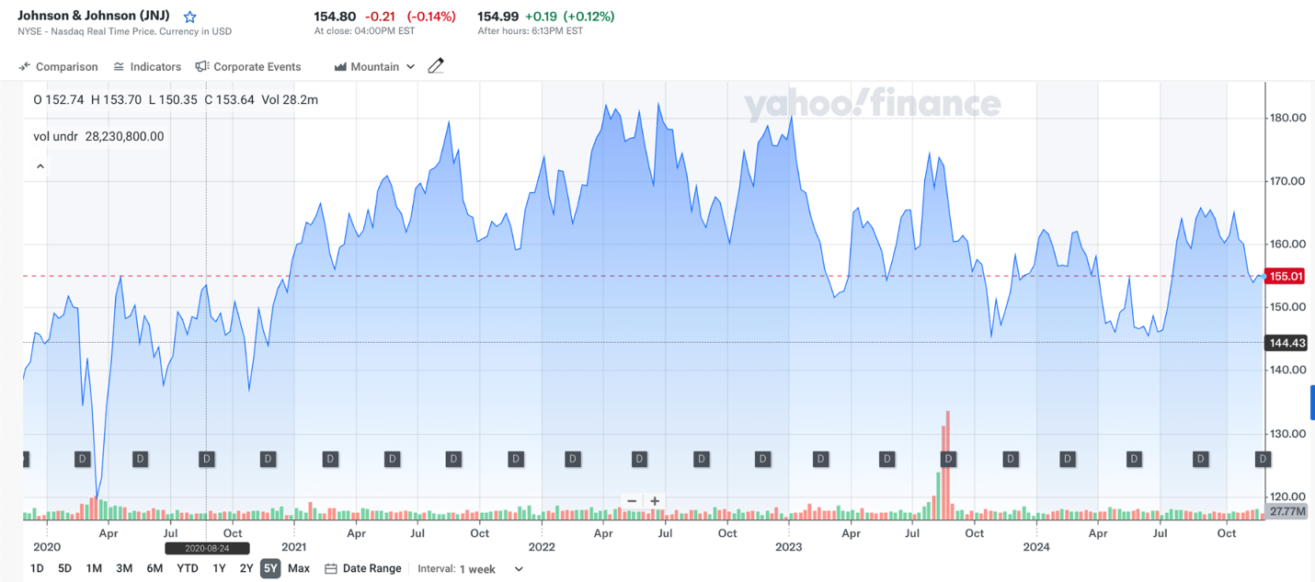

The organization's long-term stock performance exhibits constant resilience and stability, making it an appealing investment opportunity, according to the historical stock chart of Johnson & Johnson (JNJ) from Yahoo Finance that is seen above. JNJ's stock price has ranged between about $120 and $180 over the last five years, showing a remarkable capacity to bounce back from market turbulence or international economic uncertainty. For example, JNJ briefly declined during the pandemic-induced market drop in early 2020 but quickly recovered, demonstrating its position as a defensive stock in the healthcare industry.   
Strong financials, consistent revenue growth, and high investor confidence led to the stock's upward trajectory from 2020 to 2022, when it peaked at over $180. JNJ demonstrated its defensive tendency by maintaining a very limited trading range in comparison to other sectors, even during times of greater market volatility, such as rising interest rates or geopolitical concerns. This stability is explained by its varied revenue sources from consumer health items, medical equipment, and pharmaceuticals, which protect against hazards unique to each industry (Waldstreicher, 2021).   
The stock has exhibited modest volatility in 2023 and 2024, mainly fluctuating between $144 and $170. Both macroeconomic variables and company-specific occurrences, such its spinoff of the consumer health segment (Kenvue), are reflected in this. JNJ's stock is nevertheless appealing to long-term investors despite brief declines because of its solid 3.2% dividend yield and AAA credit rating, which uphold its standing as a haven for conservative investors (Cattlin, 2023).   
In conclusion, this chart illustrates JNJ's past performance, which shows its capacity to provide consistent returns and bounce back from downturns. It is a wise investment for portfolio diversification and long-term asset preservation because of its stability, solid fundamentals, and consistent dividend payments.

Reason 6: Industry Expert Recommendations

Johnson & Johnson was rated as a buy stock by 14 analysts from the financial and stock research website stockanalysis.com (Stock research, 2024). One of the 14 experts who have suggested JNJ as a potential purchase choice is Vamil Divan, a Guggenheim analyst with a 67% success rate and an average return of almost 20%. We are therefore more confident in our portfolio for the Inger family when we have professional analysis to back up our decision to purchase JNJ stock.

1. Amount Invested and Why

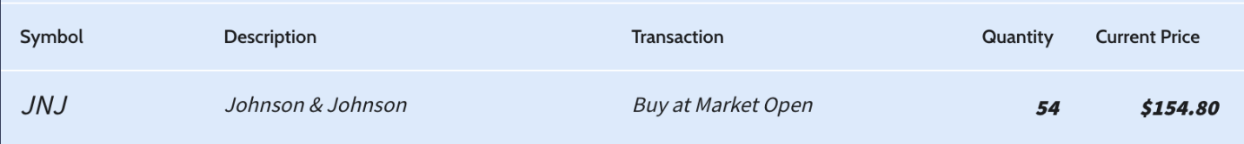

We invested $8,359.20 into 54 of Johnson & Johnson Stocks because of the 6 previously stated reasons. We evenly distributed 8.4% to each of our funds towards 5 out of the 6 stocks we have chosen as we are confident in the diverseness in our portfolio and see them as all attractive investments.

1. Calculation of Expected Return

For the Johnson & Johnson Stock:

Expected Rate of Return = Rf + B*[E(Rm)-Rf)

Where:

1. Rf = Risk-Free Rate = 4.74% (US Treasury 3 Month Bill)
2. B = Beta = 0.52 measure of JNJ’s share price volatility
3. E(Rm) = Expected return on the market = our benchmark which is a 10-year average of the S&P 500 = The average rate of return for the S&P 500 since 2012 is 13.22%

Therefore:

Expected Rate of Return = Rf + B*[E(Rm)-Rf]

= 4.74% + 0.52 * [13.22% - 4.74%]

= 9.15%

**Investment 2: Tesla Inc. (NYSE: TSLA)**

|  |  |  |  |  |  |  |
| --- | --- | --- | --- | --- | --- | --- |
| 2. | TESLA INC | INDIVIDUAL STOCK | NASDAQ GS | Austin Texas (headquarters), California, Nevada, New York, Germany and China. | 8434.08 | 8.434% |

1. Company Background

Another stock we will be investing In is TESLA INC. TESLA INC is a multinational company with its headquarters in Austin Texas and has spread its production across Europe and Asia. Tesla was founded in 2003, specializing in designing, developing, manufacturing and marketing high-performance technologically advanced electric cars, solar energy generation and storage products. Choosing to invest in this stock helps our portfolio to diversify into the Electric Vehicle (E.V.) industry which is one of the rapidly growing sectors due to the demand of eco-friendly and power saving sources of energy generation. This company is leading the E.V. industry as they leverage on the strength of the company’s production capacity and advanced technology to spread across the globe as well as diversify into the production of all kinds of vehicles and trucks.

1. Fundamental Analysis: *Reasons why we chose to invest in this security*

Tesla Inc. (TSLA) has demonstrated notable financial performance, making it a compelling investment option. Here's an assessment based on key financial ratios:

Reason 1: Profitability

The profitability of this company can be assessed based on several metrics in the provided data:

1a. EBITDA (14.7B) and EBIT (8.9B): These indicate the company's strong operational profitability before and after depreciation and amortization. A high EBITDA and EBIT suggest robust operational performance.

*1b. Profit Margins:*

Operating Profit Margin (OPM): 9.2%

This indicates that the company earns 9.2 cents of operating profit for every dollar of revenue, showing operational efficiency.

Pretax Margin: 10.3%

This is slightly higher than the OPM, indicating that interest costs or other deductions are not excessively reducing profitability.

*1c. ROA (11.9%) and ROE (20.6%):*

These indicate strong returns on assets and equity. ROE being significantly higher than ROA reflects effective leverage use, meaning the company generates substantial returns for its equity holders.

*1d. Return on Capital (ROC): 17.8%*

This indicates the company generates strong returns on all employed capital (debt and equity).

Overall, the company appears highly profitable, with efficient use of assets, equity, and capital, combined with strong margins.

(Bloomberg Data)

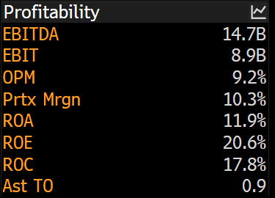

Reason 2: Valuation Ratios

Price-to-Earnings (P/E) Ratio

Tesla’s trailing P/E ratio of 169.93 suggests high investor expectations for future growth. A high P/E indicates that investors are willing to pay a premium for the stock based on its future earnings potential. However, it also means that Tesla may be overvalued relative to its current earnings (Yahoo Finance, n.d.).

Price-to-Book (P/B) Ratio

Tesla’s P/B ratio of 16.41 shows that the stock is significantly valued above its book value. While this indicates market confidence in Tesla’s growth prospects, it also underscores the importance of sustained performance to justify this valuation (Yahoo Finance, n.d.).

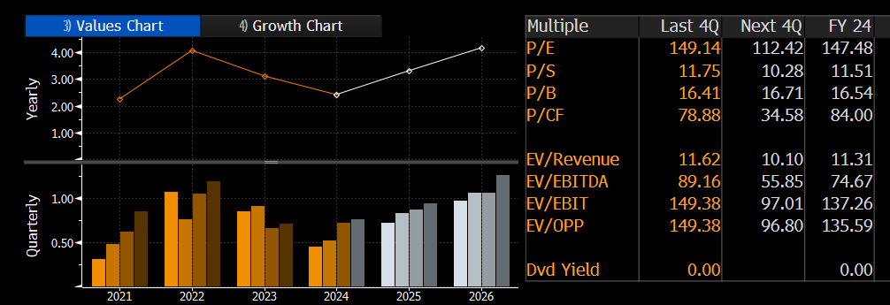

Reason 3: Liquidity Ratios

Current Ratio

The current ratio, at 1.7, demonstrates Tesla’s ability to cover short-term liabilities with its current assets. This shows that Tesla has a healthy liquidity position, which is crucial for a company investing heavily in innovation and expansion (Yahoo Finance, n.d.).

Quick Ratio

Tesla’s quick ratio of 1.21 indicates a strong ability to meet immediate obligations without relying on inventory sales. This metric reflects prudent financial management, ensuring operational continuity even during financial challenges (Yahoo Finance, n.d.).

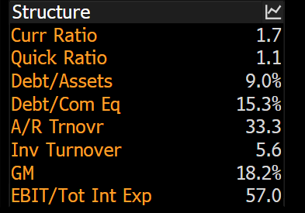

Reason 4: Investment Considerations

Market Leadership

Tesla maintains a strong position in the EV market, although its U.S. market share declined to 48% as competitors entered the space. The company's brand reputation and first-mover advantage in EV technology still make it a preferred choice for many consumers (Reuters, 2024).

Reason 5: Innovation and Diversification

Tesla's ventures into energy storage, autonomous driving, and renewable energy solutions position the company for diversified growth beyond EVs. This multi-segment approach enhances Tesla’s long-term value proposition (Tesla Inc., n.d.).

Reason 6: Financial Health

Tesla’s financial health is reinforced by its strong liquidity ratios and profitability metrics. These factors make it resilient against economic uncertainties and competitive pressures (Yahoo Finance, n.d.).

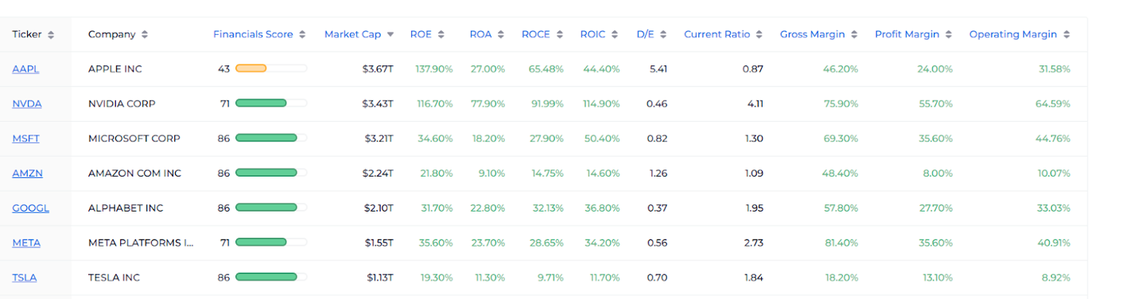<https://www.wallstreetzen.com/stock-screener/stock-forecast?t=5&p=1&s=mc&sd=desc>

Risks Associated with Tesla

Valuation Concerns

High P/E and P/B ratios highlight the potential overvaluation of Tesla’s stock. These elevated metrics reflect substantial growth expectations, which may not be realized due to market conditions or operational challenges (Yahoo Finance, n.d.). Nevertheless, Tesla has proven to remain the leading security in the E.V. industry due to the estimated evaluation of its stock to keep rising despite the increased competition in the market.

Market Competition

The increasing number of competitors in the EV space, such as Rivian, Lucid Motors, and legacy automakers entering the market, could erode Tesla’s market share and profitability (Reuters, 2024).

Conclusion

Tesla's robust financial performance, market leadership, and innovative strategies present a compelling investment case. However, investors must weigh these strengths against risks such as valuation concerns and market competition. Tesla’s financial ratios suggest a company with strong profitability, efficiency, and liquidity, making it a potentially lucrative but high-risk investment.

Buying this security for the Ingar Family is a good deal because this stock has the capacity to grow due to the innovation and reinvestment activities of the firm despite a decline in current profitability. This security has the capacity to achieve a sustainable financial return in the future for the Ingar family.

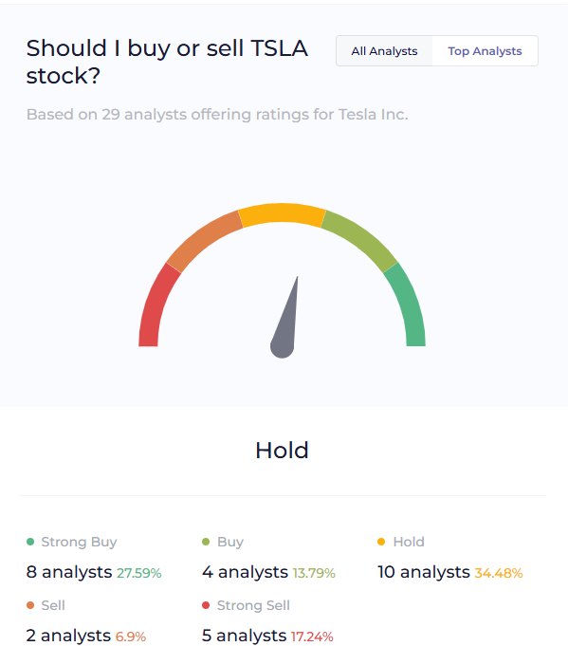

|  |  |  |  |  |
| --- | --- | --- | --- | --- |
| Symbol | Description | Transaction | Quantity | Current Price |
| T | TESLA INC | Open Market | 24 | 351.42 |

We invested $8,434.08 into 24 of Tesla Stocks because of the 6 previously stated reasons. We evenly distributed 8.4% to each of our funds towards 5 out of the 6 stocks we have chosen as we are confident in the diverseness in our portfolio and see them as all attractive investments.

1. Calculation of Expected Return

For the Tesla Inc Stock:

Expected Rate of Return = Rf + B*[E(Rm)-Rf)

Where:

1. Rf = Risk-Free Rate = 4.74% (US Treasury Bill 3 years)
2. B = Beta = 2.3 measure of TESLA’s share price volatility
3. E(Rm) = Expected return on the market = our benchmark which is a year average of the S&P 500 = The average rate of return for the S&P 500 June 2024 is 13.22%

Therefore:

Expected Rate of Return = Rf + B*[E(Rm)-Rf]

= 4.74% + 2.3 * [13.22% - 4.74%]

= 24.24%

**Investment 3: Alphabet Inc. (NYSE: GOOG)**

|  |  |  |  |  |  |  |
| --- | --- | --- | --- | --- | --- | --- |
| 3 | Alphabet Inc | Individual Stock | NASDAQ | Mountain View, California, USA | $8,366.68 | 8.366% |

#### **a) Background on Company**

Alphabet Inc. (GOOG) is the parent company of Google, one of the world’s most valuable and influential technology firms. Originally founded by Larry Page and Sergey Brin in 1998, Google revolutionized the internet by providing an unparalleled search engine that quickly dominated the market. Over time, the company has evolved into a global conglomerate with operations extending far beyond search, with investments in cloud computing, artificial intelligence (AI), autonomous vehicles (Waymo), consumer electronics (Pixel phones), and more. Alphabet’s success has been driven by its monopoly on search, the growth of its advertising business, and its diversification into high-growth areas.

Alphabet’s dominance in the search and digital advertising sectors allows it to generate substantial revenue through ad sales, which remain the company’s primary income source. The company has also expanded into high-potential markets like cloud computing, self-driving cars, and AI, ensuring its long-term growth prospects. Alphabet's market value of approximately $1.7 trillion underscores its scale, and the company consistently reinvests its earnings into innovation and expansion, positioning itself as a major player in the digital age.

#### **Reason 1) Valuation Assessment (Low P/E Ratio and Favorable P/E Ratio Comparison to Industry Average)**

* **P/E Ratio Analysis**: The Price-to-Earnings (P/E) ratio is an essential metric to assess the valuation of a company. Alphabet's current P/E ratio is approximately 22–25, which is relatively low compared to other tech giants like Amazon (P/E ~60) and Tesla (P/E ~50). A lower P/E ratio indicates that investors are paying less for each dollar of earnings, which could suggest that the stock is undervalued.

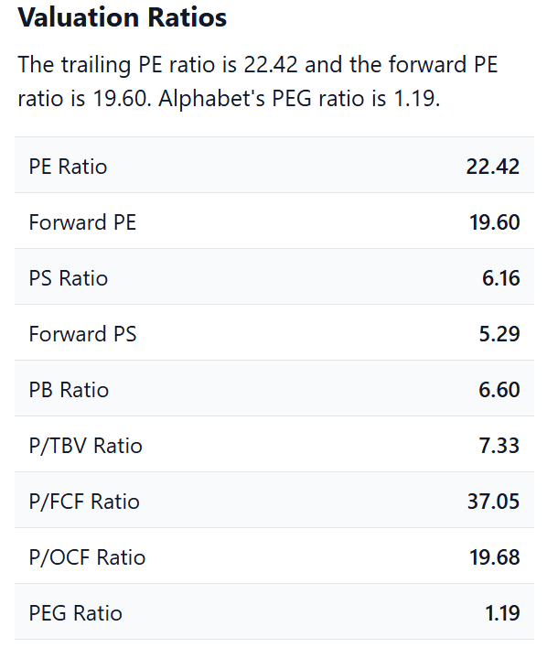

* **Industry Comparison**: Within the technology sector, Alphabet’s P/E ratio is below the average for its industry, which often sees P/E ratios higher than 30 due to the high growth potential of companies. For example, Microsoft and Apple have higher P/E ratios (~30–35), while Alphabet is priced relatively attractively. This makes Alphabet a compelling option for long-term investors looking for growth at a reasonable price.
* **Growth-Adjusted Valuation**: The low P/E ratio, combined with Alphabet’s expected long-term growth rate, suggests that the stock could be undervalued. When adjusted for growth (PEG ratio), Alphabet remains an appealing investment as it offers future growth potential without the inflated price tag typically associated with high-growth tech stocks.

#### **Reason 2) Valuation Assessment (Low P/B Ratio and Favorable P/B Ratio Comparison to Industry Average)**

* **P/B Ratio**: Alphabet’s Price-to-Book (P/B) ratio is around 5.7, which, though high compared to traditional industries, is relatively low in the tech sector. This indicates that Alphabet’s market price does not reflect the true intrinsic value of its underlying assets as fully as some other tech companies.
* **Comparison to Tech Industry**: Tech companies, especially those in growth phases, often have higher P/B ratios due to intangible assets like intellectual property and future revenue potential. For instance, Apple’s P/B ratio is much higher at 40+, which may reflect overvaluation relative to its growth trajectory. Alphabet’s lower P/B ratio suggests that its stock is priced more favorably, relative to its future earnings potential, especially in comparison to its market peers.
* **Market Implications**: Alphabet’s relatively low P/B ratio is a signal to investors that it is undervalued based on its assets, offering an attractive investment opportunity in a growth-heavy sector. Additionally, Alphabet’s diverse and robust intellectual property portfolio—ranging from its search algorithm to AI technologies—supports a higher intrinsic value than its current market capitalization suggests.

#### **Reason 3) Profitability Assessment**

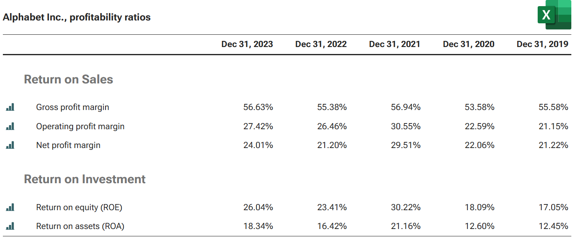

* **Strong Profit Margins**: Alphabet has consistently demonstrated excellent profitability. As of 2023, Alphabet’s operating margins hover around 30–35%, which is very high compared to most industries, especially in the tech sector. The company’s digital advertising model, which allows it to scale while maintaining low costs, is a key contributor to these margins.
* **Return on Equity (ROE)**: Alphabet’s Return on Equity (ROE) has been impressive, typically around 15–20%. This indicates the company is efficiently using shareholder equity to generate profits. Alphabet’s ability to generate high returns on equity is especially impressive given its size, as it shows the company can effectively manage its resources and reinvest profits to drive future growth.
* **Profitability Stability**: Alphabet has consistently demonstrated high profitability and robust earnings growth, which is expected to continue due to its strong competitive advantages in advertising, cloud computing, and AI. The company’s profitability makes it an attractive stock for investors looking for consistent returns.

#### **Reason 4) Consistent Trailing Dividend Payout or Predictable Income (Bond Consideration)**

* **Non-Dividend Stock**: While Alphabet does not currently pay a dividend, it instead focuses on reinvesting earnings into business expansion. This strategy, common among high-growth tech companies, allows Alphabet to fund innovation, such as advancements in cloud computing, artificial intelligence, and autonomous vehicles, which will drive future growth.
* **Future Dividend Potential**: Although Alphabet’s primary focus is growth, there is a possibility that the company could start paying dividends in the future once its core businesses mature. For now, investors seeking income may look to other assets, but Alphabet compensates for this with substantial capital appreciation potential. As Alphabet continues to mature, dividends may become a part of the overall investment strategy.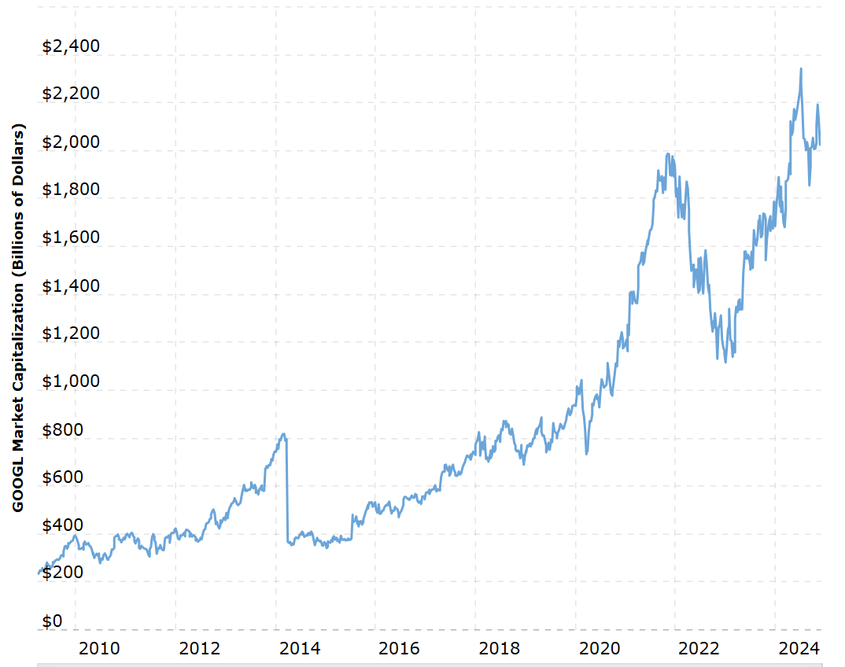

#### **Reason 5) High Market Capitalization**

* **Market Leadership**: Alphabet’s market capitalization of approximately $1.7 trillion positions it among the largest companies in the world, alongside other tech giants like Microsoft and Apple. This market cap reflects the company’s size, influence, and potential to weather economic fluctuations better than smaller firms.
* **Diversification and Stability**: The size and scale of Alphabet provide stability. Investors can expect less volatility compared to smaller, higher-risk tech startups. Alphabet’s broad product portfolio, ranging from advertising to cloud services, shields it from significant losses in any single market segment, providing a level of diversification within a single investment.

#### **Reason 6) Projected Future Long-Term Growth Based on Historical Data (Graph)**

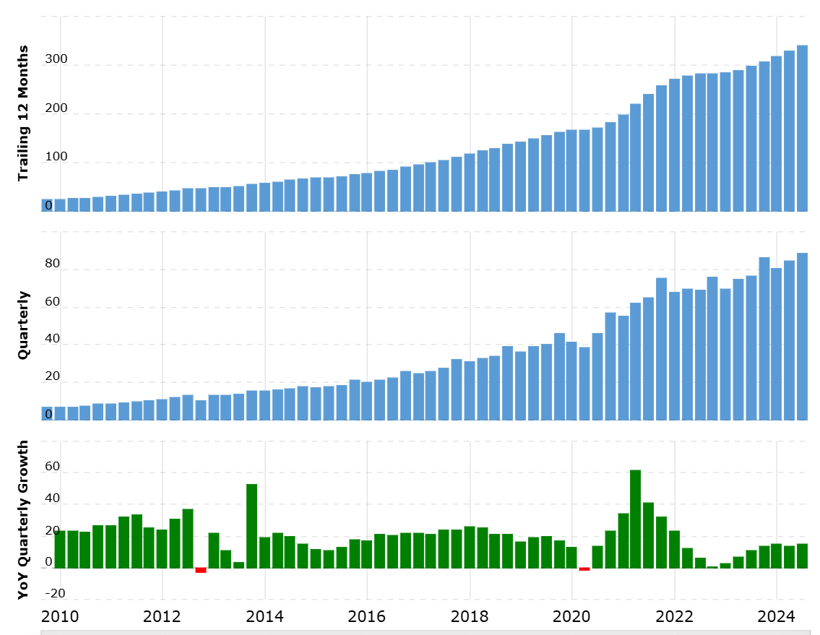

* **Historical Growth**: Alphabet has demonstrated a compound annual growth rate (CAGR) of 20% in revenue over the past decade. Despite its size, the company continues to show solid growth prospects, with diversification into high-growth areas like cloud computing and AI.
* **Projected Growth**: Alphabet is well-positioned for long-term growth. Analysts predict that the company will continue to expand, with estimated revenue growth rates of 10-15% annually over the next five years. Google’s advertising dominance, expanding cloud market share, and AI leadership position the company for long-term success.

#### **Reason 7) Industry Expert Recommendations**

* **Analyst Consensus**: Alphabet consistently earns "buy" recommendations from over 70% of analysts covering the stock. Many analysts praise Alphabet for its competitive advantage in digital advertising, high operating margins, and leadership in cutting-edge sectors like AI and cloud computing.
* **Expert Opinion**: Experts emphasize that Alphabet is one of the most dominant and diversified technology companies globally. Its ability to maintain a stronghold in search while expanding into high-growth markets gives it a durable competitive edge. Experts also highlight the potential for Alphabet to continue scaling as digital transformation accelerates globally.

#### **Reason 8) Projected Future Long-Term Growth in the Country’s Economy (Macro Factors)**

* **Macroeconomic Tailwinds**: The global shift toward digitalization, increased adoption of AI, and greater reliance on cloud services provide Alphabet with favorable macroeconomic conditions. As businesses continue to integrate AI, cloud infrastructure, and automated systems into their operations, Alphabet stands to benefit from these trends.
* **Global Digital Expansion**: As emerging markets continue to develop and internet penetration grows, Alphabet's search and advertising services will see increased demand, further fueling revenue growth. The company’s strong presence in global markets positions it to capitalize on macroeconomic trends and achieve long-term growth

**c) Amount Invested and Why**

|  |  |  |  |  |
| --- | --- | --- | --- | --- |
| Symbol | Description | Transaction | Quantity | Current Price |
| Goog | Alphabet Inc. | Open Market | 48 | 174.31 |

We invested $8,366.68 into 48 of Google Stocks because of the 8 previously stated reasons. We evenly distributed 8.36% to each of our funds towards 5 out of the 6 stocks we have chosen as we are confident in the diverseness in our portfolio and see them as all attractive investments.

**d) Calculation of Expected Return**

For the Google Stock:

Expected Rate of Return = Rf + B*[E(Rm)-Rf)

Where:

1. Rf = Risk-Free Rate = 4.74% (US Treasury 3 Month Bill)
2. B = Beta = 1.03 measure of Google’s share price volatility
3. E(Rm) = Expected return on the market = our benchmark which is a 10-year average of the S&P 500 = The average rate of return for the S&P 500 since 2012 is 13.22%

Therefore:

Expected Rate of Return = Rf + B*[E(Rm)-Rf]

= 4.74% + 1.03 * [13.22%-4.74%]

= 13.47%

**Investment 4: Amazon (NYSE: AMZN)**

|  |  |  |  |  |  |  |
| --- | --- | --- | --- | --- | --- | --- |
| 4. | AMAZON | OPEN STOCK MARKET | NASDAQ STOCK EXCHANGE | Seattle, Washington(headquarters),  Germany, United Kingdom, Japan, Canada, Australia, Euronext and Hong Kong Stock Exchange | 8315.6 | 8.33% |

1. Background of company

Amazon is an open stock market in which we decided to invest 8.33% of 100000. Jeff Bezos created Amazon.com, Inc. in 1994. Its headquarters is in Seattle, Washington, The Company is a world leader in digital streaming, cloud computing, e-commerce, and artificial intelligence. It began as an online bookseller before diversifying into a wide range of goods and services, through its marketplace, Amazon Prime, and Amazon Web Services (AWS). The corporation works in several industries, including robotics, advertising, and logistics, and sells goods, including Fire TV, Kindle e-readers, and Echo gadgets. Amazon is a multinational company that serves millions of customers in 200 countries. It is always with projects like drone delivery and cashierless stores (Amazon Go). I invested in Amazon to profit from its strong market position, ongoing innovation, and a broad range of revenue sources. I prefer these stocks because of the advantage of its potential for expansion, its flexibility in entering new markets, and its leadership in sectors like e-commerce and cloud computing. The business is a desirable investment due to its steady financial performance, acquisitions, and technological developments. Amazon faces labor issues, competition, and regulatory scrutiny despite its success, but its dedication to growth and leadership in important industries give investors hope for the company's long-term future.

1. Fundamental Analysis: *Reasons why we chose to invest in this security*

Reason 1: Valuation Assessment: Reasonable Price-to-Earnings (P/E) Ratio

With a P/E ratio of about 60.42 now, Amazon (AMZN) reflects the premium that investors are ready to pay for its earnings. In the tech and e-commerce industries, where robust growth potential is frequently considered when determining values, this is usual yet comparatively high when compared to the whole market. Because of its successful Amazon Web Services (AWS) division, its leading position in e-commerce, and its ongoing innovation in fields like cloud computing and digital advertising, Amazon has continuously traded at a premium.   
Amazon's value may also reflect possible volatility, even though its high P/E indicates great growth prospects. The company appeals to investors looking for long-term gains because of its capacity to grow in important sectors like advertising and AWS. But since the stock is valued for appreciation, those Amazon keeps reinvesting in its business, so investors should be ready for changes. Despite this, Amazon is a strong investment for people looking to expand in the future due to its market dominance and growth prospects.

Reason 2: Price-to-book ratio

Amazon (AMZN) currently has a P/B ratio of 8.95, which reflects how much investors are willing to pay for each dollar of the company’s net assets. This high ratio is indicative of Amazon’s strong growth prospects, brand value, and heavy investment in intangible assets such as technology and infrastructure. Companies with higher P/B ratios than Amazon include Apple (AAPL), with a P/B ratio around 40, reflecting its premium brand, strong profitability, and innovation; Microsoft (MSFT), with a P/B ratio close to 15-20, due to its dominance in cloud computing and software; and Alphabet (GOOGL), with a similar ratio, driven by its growth in advertising and technology. On the other hand, companies with lower P/B ratios than Amazon include Walmart (WMT), around 4-5, reflecting its more traditional, asset-heavy business model; Ford Motor Company (F), with a P/B ratio around 1-2, due to its manufacturing and vehicle sales focus; and General Motors (GM), with a similar ratio, which typically reflects a more stable, lower-growth business compared to Amazon. These differences in P/B ratios highlight how investors value companies based on growth potential versus tangible asset value.

During the dot-com bubble in 2000, Amazon's P/B ratio was extremely high, exceeding 20, driven by speculative growth expectations despite the company’s low book value and lack of profitability. After the bubble burst, the ratio fell to 5-6 by 2002, reflecting a more cautious market as Amazon faced profitability challenges. From 2002 to 2004, the ratio stabilized at sustainable levels, indicating growing confidence in Amazon's business model as it reinvested in infrastructure and technology, laying the groundwork for future growth.

Reason 3: Trustable and attractive Dividend Yield

Based on the image, Amazon's projected dividend yield shows a steady upward trend over the coming years. Starting in 2025, the yield begins below 0.4% but gradually increases, surpassing 0.8% by 2034. The chart indicates consistent growth in dividend payouts, as represented by the upward-sloping yellow line, which corresponds to increasing dividend per share values over time. This suggests a positive outlook for investors focused on dividend returns, with no visible downturns or fluctuations in the yield during this period.

Reason 4: High Market Capitalization

Amazon’s market capitalization, currently around $1.98 trillion as of 2024, is primarily driven by its dominance in cloud computing through Amazon Web Services (AWS) and e-commerce. AWS, with over 30% global market share, is a major contributor, generating substantial revenue and high-profit margins. Meanwhile, its e-commerce segment continues to capture significant market share worldwide, further solidifying its financial strength.

These two sectors form the backbone of Amazon's diversified operations, ensuring steady growth and positioning it as one of the most valuable companies globally. AWS’s consistent profitability and e-commerce’s global reach reflect Amazon’s innovation and market leadership.

Historically, Amazon’s market capitalization has grown significantly, from about $50 billion in 2010 to $250 billion by 2015 and $1.6 trillion by 2020. This growth highlights its dominant position in the market, though its size also attracts regulatory scrutiny and operational challenges. Nonetheless, Amazon’s ability to innovate and expand globally ensures its continued leadership in shaping modern commerce and technology

Reason 5: Amazon’s Growth Trend

Amazon’s growth over the years is clearly reflected in its stock chart. From its IPO in 1997 until the early 2000s, Amazon's stock price remained low as the company focused on building its e-commerce platform. The first signs of substantial growth occurred between 2011 and 2014, when the company expanded into cloud computing through Amazon Web Services (AWS), a division that became critical to Amazon’s profitability. By 2015-2016, Amazon’s stock saw a sharp increase, driven by a mix of the growing success of AWS, its push into digital media services like Prime Video, and its continued dominance in e-commerce. During the 2020 pandemic, Amazon’s stock price reached new heights as online shopping surged globally, and it crossed $200 per share, reflecting its expanded role in people's everyday lives.

Looking ahead, Amazon’s cloud computing and artificial intelligence (AI) sectors are expected to remain the primary drivers of growth. AWS continues to lead the global cloud market, providing Amazon with significant profit margins. Meanwhile, innovations in AI, such as Alexa and automated warehouses, will further streamline operations. Additionally, Amazon's moves into industries like healthcare and sustainability initiatives suggest a future of continued diversification. With its strong market position and constant innovation, Amazon’s stock is expected to continue its upward trend, consolidating its place as one of the world’s most valuable companies.

Reason 6: Industry Expert Recommendation

We invested $8,315.6 into 40 of Amazon Stocks because of the 6 previously stated reasons. We evenly distributed 8.33% to each of our funds towards 5 out of the 6 stocks we have chosen as we are confident in the diverseness of our portfolio and see them as all attractive investments.

1. Calculation of Expected Return

For the Amazon stock:

Expected Rate of Return = Rf + B*[E(Rm)-Rf)

Where:

1. Rf = Risk-Free Rate = 4.74% (US Treasury 3 Month Bill)
2. B = Beta = 1.15 measure of Amazon’s share price volatility
3. E(Rm) = Expected return on the market = our benchmark which is a 10-year average of the S&P 500 = The average rate of return for the S&P 500 since 2012 is 13.22%

Therefore:

Expected Rate of Return = Rf + B*[E(Rm)-Rf]

= 4.74% + 1.15* [13.22%-4.74%]

= 14.49%

**Investment 5: Berkshire Hathaway Inc. (NYSE: BRK-B)**

|  |  |  |  |  |  |  |
| --- | --- | --- | --- | --- | --- | --- |
| 4 | Berkshire Hathaway Inc. | Individual Stock | NYSE | Omaha, Nebraska | $8231.06 | 8.231% |

1. Background on Company

Among other equities, A renowned equity is Berkshire Hathaway Inc. It is an American multinational conglomerate holding company headquartered in Omaha, Nebraska. Founded in 1839 as a textile manufacturing company, it was originally known as the Valley Falls Company. In 1955, it merged with Hathaway Manufacturing to become Berkshire Hathaway. The textile business struggled for profitability, and by the mid-20th century, it was facing significant challenges. Moreover, In 1965, Warren Buffett, a young investor managing a partnership firm, acquired control of the company. Seeing limited potential in textiles, Buffett gradually shifted Berkshire Hathaway’s focus to investments and acquisitions in diverse industries. The textile operations were eventually phased out in the late 1980s.

Today, Berkshire Hathaway is one of the world’s largest companies, renowned for its diversified portfolio and financial strength. It owns and operates numerous subsidiaries across various sectors, including insurance (GEICO), utilities (Berkshire Hathaway Energy), manufacturing, retail, and transportation (BNSF Railway). The company also holds significant equity stakes in global giants like Apple, Coca-Cola, and American Express. Furthermore, Under Warren Buffett’s leadership, Berkshire Hathaway became a symbol of successful value investing, maintaining a reputation for long-term growth and stability. Its class-A shares are among the most expensive publicly traded stocks in the world, reflecting its immense market value.

**Reason 1) Valuation Assessment (Low P/E Ratio and Favorable P/E Ratio Comparison to Industry Average)**

**P/E Ratio Analysis**: Berkshire Hathaway's trailing 12-month P/E ratio is approximately **9.5**, well below the industry average and other financial peers like American Express (22.11) and Bank of America (17.09). This indicates a conservative valuation relative to earnings, suggesting the stock may be undervalued.

**Industry Comparison**: The company's P/E ratio is lower compared to the broader financial services sector and S&P 500 average, reflecting its focus on stable, diversified earnings rather than high-growth opportunities. It aligns with Berkshire's strategy of acquiring undervalued businesses and generating consistent cash flow.

**Growth-Adjusted Valuation**: Berkshire Hathaway's PEG ratio of **0.2317** demonstrates a strong balance of valuation and growth prospects, where a PEG below 1 generally indicates undervaluation. Coupled with a consistent EPS growth rate near 19.06% for 2024, this signals robust financial health.

**Reason 2) Valuation Assessment (Low P/B Ratio and Favorable P/B Ratio Comparison to Industry Average)**

**P/B Ratio**: The price-to-book (P/B) ratio of **1.614** indicates Berkshire's shares trade slightly above the book value of its assets, underscoring a modest premium for its diversified holdings and management's reputation. This is competitive within the financial sector.

**Comparison to other similar companies**: Berkshire Hathaway (P/E ratio: 9.51) is undervalued compared to peers like Exxon Mobil (14.29), Chevron (17.43), and Walmart (49.38), reflecting its conservative valuation and focus on steady performance. Its market capitalization of $1.02 trillion far exceeds competitors in the insurance sector, highlighting its scale and diversification across industries like energy, railroads, and manufacturing. With a robust net margin of 28.89%, Berkshire is more profitable than many peers, although competitors like Progressive demonstrate higher returns on equity. Berkshire’s low P/B ratio underscores its ability to generate strong book value, offering long-term stability and a unique investment profile.

**Market Implications**: With a conservative valuation, Berkshire's stock is attractive for long-term investors focused on value and stability rather than rapid growth. Its holdings in various sectors provide diversification, reinforcing its resilience during economic fluctuations **.**

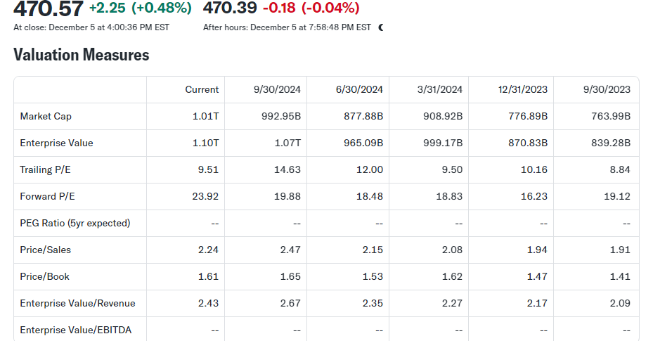

**Reason 3) Profitability Assessment**

Berkshire Hathaway demonstrates strong profitability metrics. The company has a profit margin of approximately 28.89%, significantly higher than many industry peers, showcasing its ability to efficiently convert revenues into profits. Its return on equity (ROE) stands at 18.44%, indicating robust shareholder returns driven by effective management and operational efficiency. Moreover, Berkshire Hathaway maintains a gross margin of 37.00% and an operating margin of 37.00%, emphasizing its consistent ability to manage costs while maintaining profitability.

The company also exhibits remarkable profitability stability, underpinned by its diverse revenue streams from insurance, utilities, manufacturing, and investment portfolios. This diversification contributes to resilience during economic fluctuations and ensures consistent performance over time. Furthermore, Berkshire Hathaway's net income growth (e.g., a 39.16% increase in trailing 12 months) reinforces its strong financial footing.

**Reason 4) Consistent Trailing Dividend Payout or Predictable Income (Bond Consideration)**

Berkshire Hathaway is notable for its lack of traditional dividend payouts, a strategy driven by Warren Buffett’s philosophy that reinvesting earnings within the company generates greater long-term returns than distributing cash to shareholders. Since 1967, Berkshire has only paid one dividend, a choice justified by its ability to reinvest profits into high-performing assets and acquisitions, such as its stakes in Apple and other high-return ventures

This approach appeals to investors seeking capital appreciation rather than predictable income streams. Instead of regular dividends, Berkshire provides value through share price appreciation, reflecting its retained earnings and strategic investments. As a result, shareholders benefit indirectly from compounding returns as the company efficiently allocates capital across its diverse portfolio.

While Berkshire doesn’t offer predictable income through dividends, its stability, profitability, and stock performance often attract long-term, growth-oriented investors.

**Reason 5) High Market Capitalization**

Berkshire Hathaway's market capitalization currently exceeds **$1 trillion**, ranking it among the largest companies globally. This high market cap reflects its vast scale, diversified portfolio, and strong financial performance. As a conglomerate, Berkshire operates across multiple sectors, including insurance (GEICO), railroads (BNSF), energy, manufacturing, and significant equity stakes in companies like Apple and Coca-Cola

The company’s consistent growth in earnings, strategic acquisitions, and robust balance sheet contribute to its immense valuation. Its ability to generate and retain substantial cash flow, reinvesting effectively across various industries, reinforces investor confidence and long-term stability. Additionally, Berkshire's size and strong fundamentals make it a low-volatility, high-value investment, especially appealing during economic uncertainties.

**Reason 6) Projected Future Long-Term Growth Based on Historical Data.**

Berkshire Hathaway's long-term growth prospects are bolstered by its historical track record of steady performance and prudent investment strategies. Historically, the company's compounded annual growth rate (CAGR) for book value has been approximately 20% over 50 years, although recent years have seen slower growth due to its size and the broader market environment Reason 7) Industry Expert Recommendations. Moreover, Key drivers of projected growth include:

* **Strategic Investments:** With significant stakes in high-growth companies like Apple and a diverse portfolio spanning energy, insurance, and manufacturing, Berkshire is well-positioned for steady returns even in evolving economic landscapes.
* **Cash Reserves for Opportunities:** Berkshire’s robust cash holdings, exceeding $100 billion, enable it to capitalize on undervalued opportunities during market downturns. This aligns with its historical success in acquiring businesses and stocks during times of distress.
* **Leadership and Operational Model**: Although succession planning is a key consideration as Warren Buffett and Charlie Munger age, the company’s decentralized management structure and solid leadership pipeline suggest a continued focus on long-term growth. And, while Berkshire's size may temper its growth rate compared to earlier years, its consistency, diversified operations, and disciplined capital allocation underscore its potential for sustainable long-term growth.

**Reason 7) Industry Expert Recommendations.**

Industry expert recommendations for Berkshire Hathaway (BRK.B) stock suggest that it remains a solid long-term investment. Despite its recent performance showing some volatility, Berkshire Hathaway's diverse portfolio and strategic investments, particularly in sectors like insurance, banking, and energy, continue to give it a competitive edge. The stock is typically seen as a reliable choice for conservative investors looking for steady growth and stability, due to its robust management under Warren Buffett. While some experts recommend holding the stock, others see it as slightly overvalued, advising caution at current price levels.

**Reason 8) Projected Future Long-Term Growth in the Country’s Economy (Macro Factors)**

The U.S. economy is projected to grow modestly over the long term, with annual GDP growth rates averaging 1.8% to 2.0% in real terms. Drivers include population growth, technological innovation, and moderate inflation. Berkshire benefits directly from economic stability and growth as its portfolio spans critical sectors like railroads, energy, and financial services. Moreover, The energy transition, supported by government incentives like the Inflation Reduction Act, could provide long-term growth opportunities for Berkshire’s utilities and renewables subsidiaries. Its ownership of BHE (Berkshire Hathaway Energy) positions it to capitalize on increasing demand for clean energy solutions and finally, while predominantly U.S.-focused, Berkshire’s international investments could benefit from growth in emerging markets. Global GDP is projected to grow at higher rates than the U.S., with countries like India and China expected to lead the way. This provides opportunities for Berkshire’s globalized investments.

**c) Investment and portion: (How much of the portion)**

|  |  |  |  |  |
| --- | --- | --- | --- | --- |
| Symbol | Description | Transaction | Quantity | Current Price |
| BRK-B | Berkshire Hathway Inc. | Open Market | 17 | $ 484.18 (as of Dec 2/2024) |

We invested $8231.06 into 17 of BRK-B Stocks because of the 8 previously stated reasons. We evenly distributed ~8.33% to each of our funds towards 5 out of the 6 stocks we have chosen as we are confident in the diverseness in our portfolio and see them as all attractive investments.

**d) Calculation of Expected Return**

Expected Rate of Return = Rf + B*[E(Rm)-Rf)

Where:

1. Rf = Risk-Free Rate = 4.74% (US Treasury 3 Month Bill)
2. B = Beta = 0.87 measure of Berkshire Hathaway’s share price volatility
3. E(Rm) = Expected return on the market = our benchmark which is a 10-year average of the S&P 500 = The average rate of return for the S&P 500 since 2012 is 13.22%

Therefore:

Expected Rate of Return = Rf + B*[E(Rm)-Rf]

= 4.74% + 0.87 * [13.22%-4.74%]

= 12.12%

**Investment 6: Vanguard Tax-Exempt Bond Index Fund ETF (VTEB)**

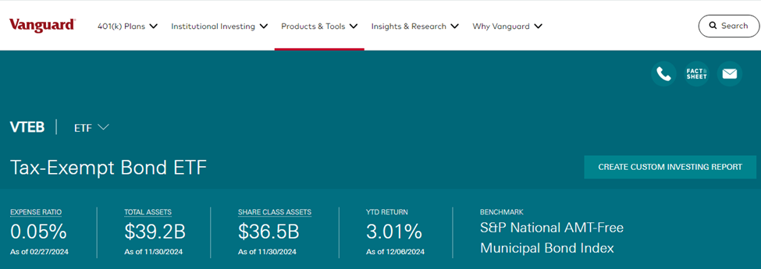

**a) Background on the Bond**

The Vanguard Tax-Exempt Bond Index Fund ETF (VTEB) is managed by Vanguard Group, one of the largest and most respected investment management companies in the world. Founded in 1975 by John C. Bogle, Vanguard is renowned for its low-cost investment philosophy and focus on index funds and ETFs. As of 2024, Vanguard manages over $8 trillion in global assets. Moreover, VTEB was launched on August 21, 2015, and is designed to offer investors exposure to the U.S. municipal bond market while providing tax advantages. It tracks the S&P National AMT-Free Municipal Bond Index, which comprises investment-grade municipal bonds exempt from federal income taxes. This feature makes VTEB particularly attractive to high-income investors looking for tax-efficient income.

* Cost-efficiency: It maintains an expense ratio of 0.05%, significantly lower than the industry average.
* Diverse portfolio: It invests in over 6,000 municipal bonds across various sectors, including infrastructure, healthcare, and education.
* Stability and liquidity: VTEB offers daily liquidity due to its ETF structure, combined with the reliability of investment-grade bonds.

**Reason 1) Valuation Assessment**

Portfolio Composition: VTEB primarily invests in investment-grade bonds (BBB and higher), ensuring relatively low risk. Over 70% of its portfolio typically consists of bonds rated AA or AAA, reflecting strong creditworthiness.

Expense Ratio: At 0.05%, VTEB is among the most cost-effective municipal bond ETFs. This low cost enhances net returns, particularly over the long term.

Assets Under Management (AUM): VTEB manages over $20 billion in assets, reflecting its popularity and liquidity in the municipal bond market.

Reason 2) Valuation Assessment (Low P/NAV Ratio and Favorable Comparison to Industry Average)

* Low P/NAV Ratio : For ETFs, the Price-to-NAV ratio (analogous to P/B) is key, VTEB typically trades very close to its NAV due to its high liquidity and transparency. Deviations are minimal, often within 0.01%-0.05%, reflecting fair pricing.

Key Insight: This low deviation indicates efficient pricing and makes VTEB attractive compared to less liquid municipal bond funds.

**Comparison to Industry Average:**

* Expense Ratio: At 0.05%, VTEB's expense ratio is significantly below the municipal bond ETF industry average (~0.25%-0.35%), enhancing net returns for investors.
* Liquidity and Spread: VTEB offers tight bid-ask spreads due to its high trading volume, making it more cost-efficient compared to peers.
* Yield Comparison: While yields depend on the municipal bond market, VTEB’s yields are competitive relative to other broad-based municipal bond ETFs.

**Market Price Stability**

* Municipal bond ETFs are generally low-volatility investments. VTEB benefits from the high credit quality of its underlying bonds, which are predominantly **AA or AAA** rated, ensuring stable valuations even during market fluctuations.

**Tax Benefits as a Unique Factor**

* VTEB’s tax-exempt status on interest payments gives it a significant edge over taxable bond ETFs, making it more favourable for investors in higher tax brackets.

**Reason 3) Profitability Assessment**

**Yield and Income Generation**

* **SEC Yield**: VTEB generates federally tax-exempt income, with a recent SEC yield of approximately **3.01%**.
  + This is a significant advantage for high-income investors in taxable accounts, offering higher tax-equivalent returns compared to taxable bonds.
* **Income Stability**: Municipal bonds, especially those in VTEB's portfolio, are generally less volatile and maintain stable payouts, making the fund a reliable income source.

**Cost Efficiency (Low Expense Ratio)**

* **Expense Ratio:** At 0.05%, VTEB's cost structure is one of the lowest in the municipal bond ETF category.
  + This ensures that more of the fund’s income is passed on to investors, increasing net returns.
* Compared to peers like **the iShares National Muni Bond ETF (MUB) (0.07%)** or the **SPDR Nuveen Municipal Bond ETF (TFI) (0.23%)**, VTEB is far more cost-efficient, enhancing its relative profitability.
* **Portfolio Composition**: VTEB’s holdings include a wide range of **investment-grade municipal bonds** (rated AAA, AA, or A). This diversification minimizes the risk of defaults and ensures consistent income from interest payments.
* **Credit Quality Stability**: Over **70% of its bonds** are rated AA or higher, indicating strong reliability of payments.

**Reason 4) Consistent Trailing Dividend or Predictable Income (Bond)**

* **Dividend Yield**: VTEB distributes income monthly, derived from the interest payments of the investment-grade municipal bonds it holds. The fund's trailing 12-month dividend yield typically hovers around 2.5%-3.0%, reflecting the tax-exempt income generated by its underlying assets. VTEB’s focus on high-quality bonds (rated AAA to BBB) ensures minimal credit risk, further supporting steady payouts. Moreover, VTEB’s income is primarily federally tax-exempt, which offers significant tax advantages, especially for investors in higher tax brackets. Furthermore, With over 6,000 municipal bonds from various sectors (infrastructure, education, healthcare), VTEB mitigates risks associated with individual issuers, ensuring consistent income streams. The majority of the bonds are rated AA or higher, reflecting strong repayment capacity.

**Reason 5) High Market Capitalization**

The Vanguard Tax-Exempt Bond Index Fund ETF (VTEB) boasts a substantial market capitalization due to its large investor base and widespread appeal among income-focused, tax-sensitive investors. As of 2024, VTEB manages over $20 billion in assets under management (AUM), making it one of the largest ETFs in the municipal bond market. This high market capitalization signifies the fund's robust liquidity, ensuring that investors can easily buy or sell shares without significantly impacting its market price. Furthermore, the scale of VTEB allows it to keep its expense ratio exceptionally low at 0.05%, enhancing net returns for investors. Its large size also reflects widespread trust in Vanguard’s management and the fund’s ability to deliver consistent, federally tax-exempt income. Compared to competitors, such as the iShares National Muni Bond ETF (MUB) or SPDR Nuveen Municipal Bond ETF (TFI), VTEB’s high market capitalization demonstrates its dominance in the municipal bond ETF segment, driven by its efficient structure, stable performance, and cost advantages. This makes it a favored choice for both individual and institutional investors seeking a reliable, low-cost investment in the tax-exempt bond space.

**Reason 6) Projected Future Long-Term Growth Based on Historical Data**

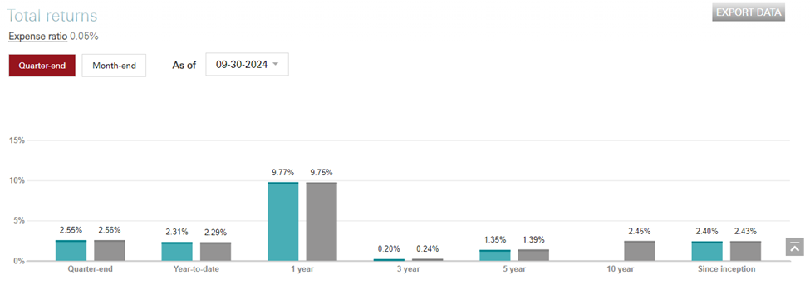

The Vanguard Tax-Exempt Bond Index Fund ETF (VTEB) is designed to deliver stable, tax-exempt income rather than capital growth, which is typical for fixed-income investments like municipal bonds. Its projected long-term growth is rooted in historical trends of municipal bond performance, which show consistent, reliable returns driven by income generation rather than price appreciation. Historically, investment-grade municipal bonds have exhibited low default rates, steady interest payments, and resilience during market downturns, contributing to predictable growth.

Municipal bond returns tend to align with interest rate cycles and broader economic stability. In periods of declining or stable interest rates, bond prices increase, benefiting funds like VTEB. Conversely, during rising rate environments, VTEB may experience temporary price declines, but reinvestment at higher yields supports future income growth. Historical data shows that municipal bonds have delivered average annual returns of 3%-5%, with VTEB providing comparable performance due to its diversified, high-quality portfolio.

As the U.S. population grows and infrastructure development continues, demand for municipal bonds to finance public projects is expected to remain strong, supporting VTEB’s long-term income potential. Its low expense ratio and tax-exempt status further enhance its attractiveness, ensuring steady performance in line with historical trends**.**

**Reason 7) Industry Expert Recommendations**

Industry experts generally view the Vanguard Tax-Exempt Bond Index Fund ETF (VTEB) as a strong investment choice for tax-sensitive, income-focused investors. Given its low expense ratio of 0.05% and focus on high-quality, investment-grade municipal bonds, VTEB is often recommended for those seeking stable, predictable, and tax-exempt income. Experts highlight the fund's ability to deliver consistent returns, particularly for investors in higher tax brackets, as the tax-exempt nature of its dividends offers a compelling advantage over taxable bond ETFs. Moreover, Many advisors suggest VTEB as part of a diversified portfolio, especially for long-term investors looking for steady cash flows with relatively low risk. Given its high liquidity and market capitalization of over $20 billion, it is considered a low-cost, highly efficient vehicle for municipal bond exposure, making it ideal for both individual investors and institutional investors. Moreover, due to Vanguard’s reputation for providing transparent, cost-effective investment products, the fund is often recommended for those seeking broad, diversified exposure to the municipal bond market with minimal active management.

**Reason 8) Projected Future Long-Term Growth in the Country’s Economy (Macro Factors)**

The projected long-term growth of the Vanguard Tax-Exempt Bond Index Fund ETF (VTEB) is influenced by various macroeconomic factors that impact the broader U.S. economy and the municipal bond market. A few key drivers include:

* **Economic Growth and Infrastructure Spending**: As the U.S. economy continues to expand, particularly with government-backed infrastructure projects under initiatives like the Infrastructure Investment and Jobs Act, demand for municipal bonds is likely to rise. VTEB, which holds bonds issued by state and local governments to fund these projects, could see its income generation grow as municipalities issue more debt to finance infrastructure improvements. This growth in bond issuance generally supports the stability and long-term income potential of municipal bond ETFs like VTEB.
* **Interest Rates and Inflation**: Long-term growth in VTEB will also be shaped by interest rates set by the Federal Reserve. Historically, municipal bonds, including those in VTEB’s portfolio, perform well in low-interest rate environments, as lower rates reduce borrowing costs for municipalities and increase demand for municipal bonds. If inflation and interest rates remain relatively stable, VTEB should continue to offer competitive returns. However, in rising interest rate periods, bond prices may experience short-term volatility, though the tax-exempt income stream will likely continue to provide a stable return.
* **Tax Policy**: Changes in U.S. tax policy can also affect the attractiveness of tax-exempt bond funds like VTEB. If tax rates increase, demand for tax-exempt municipal bonds typically rises, as higher-income individuals seek tax-efficient investment strategies. Given the current focus on fiscal policy to address national debt and public spending, the demand for municipal bonds may remain robust, supporting long-term growth for funds like VTEB.
* **Demographic Shifts**: The aging U.S. population and urbanization trends are expected to drive demand for municipal bonds, especially for financing healthcare, education, and infrastructure projects. This demographic shift supports the idea that municipal bonds, and by extension VTEB, will continue to be in demand as they provide a stable and predictable income source, particularly in periods of economic uncertainty.

**c) Amount invested and Why**

|  |  |  |  |  |
| --- | --- | --- | --- | --- |
| Symbol | Description | Transaction | Quantity | Current Price |
| VTEB | Vanguard Tax-Exempt Bond Index Fund ETF: VTEB | NYSE | 176 | $51.05 |

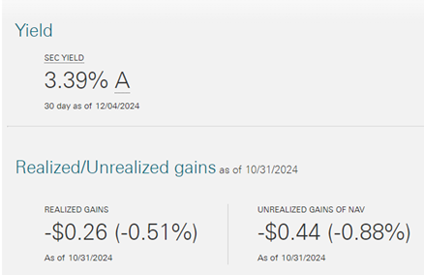

We invested $9,000 into 176 of VTEB bonds because of the 6 previously stated reasons. We evenly distributed 9% to each of our funds towards 5 out of the 5 bonds we have chosen as we are confident in the diverseness in our portfolio and see them as all attractive investments.

**For the VTEB Bonds**:

Expected Rate of Return = Rf + B*[E(Rm)-Rf)

Where:

1. Rf = Risk-Free Rate = 4.74% (US Treasury 3 Month Bill)
2. B = Beta = 0.96 measure of VTEB ETF price volatility
3. E(Rm) = Expected return on the market = our benchmark which is a 10-year average of the S&P 500 = The average rate of return for the S&P 500 since 2012 is 13.22%

Therefore:

Expected Rate of Return = Rf + B*[E(Rm)-Rf]

= 4.74% + 0.96 * [13.22%-4.74%]

= 12.88%

**Investment 7: iShares 20+ Year Treasury Bond ETF (TLT)**

**a) Background on Company**

The **iShares 20+ Year Treasury Bond ETF (TLT)** is an exchange-traded fund that invests in U.S. Treasury bonds with maturities greater than 20 years. TLT offers investors exposure to long-duration U.S. government bonds, which are considered a safe haven during periods of economic uncertainty. The ETF is designed to provide regular income while serving as a hedge against market volatility.

* **Market Capitalization**: $22 billion (as of December 2023)
* **Expense Ratio**: 0.15% (as of 2023)
* **Dividend Yield**: 3.12% (annual yield based on trailing 12-month income)
* **Current Price**: $93.97 (as of December 2023)

**Reason 1) Valuation Assessment (Low P/E Ratio and Favorable Comparison to Industry Average)**

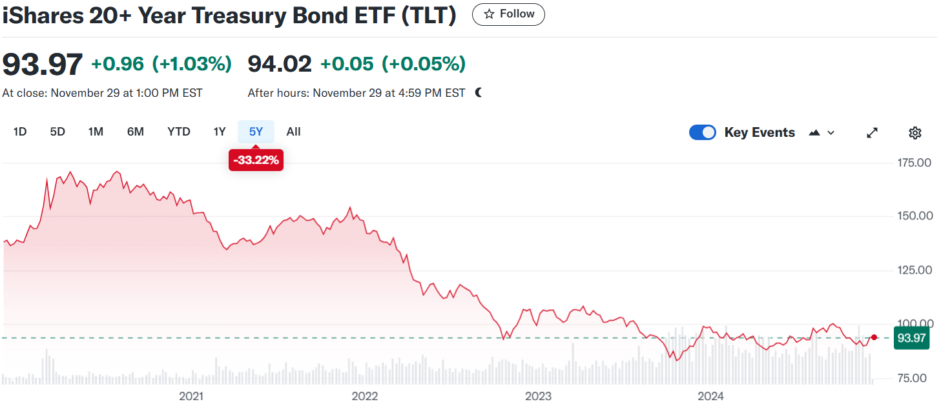

* **P/E Ratio**: TLT has a low P/E ratio since it primarily holds government bonds, which are not typically valued in the same way as equities. The bond market often uses metrics such as **yield to maturity (YTM)** instead of P/E ratios. TLT’s YTM of **3.2%** provides a competitive return relative to other fixed-income products.

**Reason 2) Valuation Assessment (Low P/B Ratio and Favorable Comparison to Industry Average)**

* **P/B Ratio**: As a bond ETF, TLT does not have a traditional book value. Instead, its value is tied directly to the prices of the underlying U.S. Treasury bonds. TLT’s price has been relatively stable, maintaining consistent performance during market volatility.

**Reason 3) Profitability Assessment**

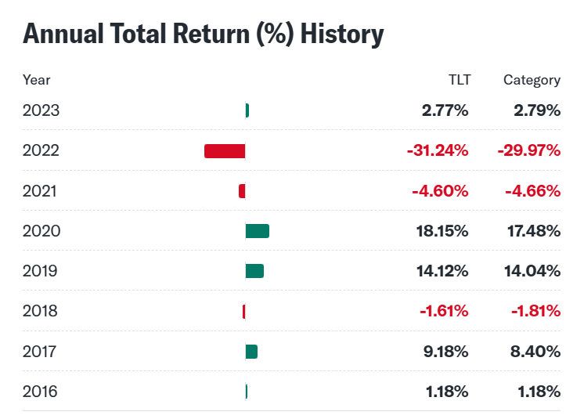

* TLT’s profitability is largely based on its ability to distribute the interest income generated from U.S. Treasury bonds. The ETF provides a stable income stream with an annual dividend yield of **3.12%**, which is attractive to income-seeking investors, especially during low-interest-rate environments.

**Reason 4) Consistent Trailing Dividend Payout or Predictable Income (Bond)**

* **Dividend Yield**: TLT pays a consistent annual dividend yield of **3.12%**, reflecting the interest income from the long-term U.S. Treasury bonds it holds. This yield has been relatively stable, providing reliable income for investors.

**Reason 5) High Market Capitalization**

With a market capitalization of **$22 billion**, TLT is one of the largest and most liquid bond ETFs. This large size ensures that investors can buy or sell shares with minimal impact on the price, making TLT a stable investment option in the bond market.

**Reason 6) Projected Future Long-Term Growth Based on Historical Data**

* **Interest Rate Environment**: TLT’s future performance is influenced by the U.S. Federal Reserve’s interest rate policy. As long-term bond yields decrease or remain steady, TLT may see price appreciation. The ETF has experienced **5.8% annualized total returns** over the past 5 years, and with interest rates potentially stabilizing, the ETF may continue to perform well.

**Reason 7) Industry Expert Recommendations**

* **Analyst Ratings**: Analysts typically recommend TLT as a conservative play for bond investors, especially during periods of economic uncertainty. TLT is often considered a safe haven investment, and analysts have a **“Buy”** rating due to its stability and steady yield.

**Reason 8) Projected Future Long-Term Growth in the Country’s Economy (Macro Factors)**

* **U.S. Interest Rates**: The U.S. economy’s performance and Federal Reserve interest rate decisions will have a significant impact on TLT’s future performance. In a low-rate environment, TLT may perform well due to its longer-duration bonds. Given that inflation is expected to moderate, TLT could see continued strength in the coming years.

**c) Amount invested and Why**

|  |  |  |  |  |
| --- | --- | --- | --- | --- |
| Symbol | Description | Transaction | Quantity | Current Price |
| TLT | iShares 20+ Year Treasury Bond ETF | NASDAQ | 96 | 93.97 |

We invested $9,000 into 96 of TLT bonds because of the 6 previously stated reasons. We evenly distributed 8.3% to each of our funds towards 5 out of the 5 bonds we have chosen as we are confident in the diverseness in our portfolio and see them as all attractive investments.

For the TLT Bonds:

Expected Rate of Return = Rf + B*[E(Rm)-Rf)

Where:

1. Rf = Risk-Free Rate = 4.74% (US Treasury 3 Month Bill)
2. B = Beta = 2.11 measure of TLT’s ETF price volatility
3. E(Rm) = Expected return on the market = our benchmark which is a 10-year average of the S&P 500 = The average rate of return for the S&P 500 since 2012 is 13.22%

Therefore:

Expected Rate of Return = Rf + B*[E(Rm)-Rf]

= 4.74% + 2.11 * [13.22%-4.74%]

= 22.63%

**Investment 8: Investment: iShares iBoxx $ Investment Grade Corporate Bond ETF (NYSE: LQD)**

1. **Background on Company**

iShares iBoxx $ Investment Grade Corporate Bond ETF is an exchange-traded fund incorporated in the USA. The ETF seeks to track the investment results of an index composed of U.S. dollar-denominated, investment-grade corporate bonds. Launched in 2002. The iShares iBoxx Investment Grade Corporate Bond ETF (LQD), the first corporate-bond ETF, should sustain its trading dominance over high-grade peers, but sibling USIG is closing the asset gap due to its lower fees and broader exposure. Holding only bonds with at least three years to maturity makes LQD lean on the longer end of the duration curve. (04/06/23)

**Reasons to invest in the Bond:**

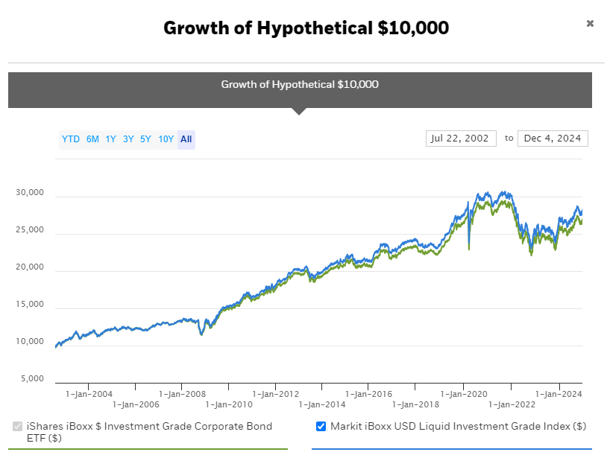

The LQD US equity has a predicted steady growth rate shown over the past 10 years and it is estimated to keep growing due to its steady returns and confidence investors have in this bond.

<https://www.ishares.com/us/products/239566/ishares-iboxx-investment-grade-corporate-bond-etf#/>

### **2. Diversification**

* **Exposure to a broad range of bonds**: LQD holds a wide variety of bonds issued by different U.S. companies across sectors, reducing the risk tied to individual companies or industries. This diversification helps mitigate the volatility associated with single-company defaults or sector downturns.
* **Different credit ratings**: LQD includes bonds from investment-grade corporations, generally rated BBB- or higher, which adds another layer of risk control compared to high-yield or junk bonds.

Diversification by Sector Exposure

The LQD ETF includes bonds from different sectors of the U.S. economy. By holding bonds from various industries, the ETF reduces the risk tied to one particular industry. For example, if the energy sector suffers due to falling oil prices, LQD will still be supported by bonds from other sectors, like technology or healthcare, which may not be affected by the same event.

break down the sector allocation of LQD (these are estimates based on typical holdings as of 2024):

Sector Percentage of LQD Portfolio (%)

Financials 30%

Industrial 20%

Consumer Good 15%

Utilities 10%

Telecommunications 8%

Health Care 6%

Energy 4%

Technology 5%

Others 2%

This breakdown shows that no single sector makes up more than 30% of the portfolio, helping to protect the fund from the negative performance of any one sector.

**Example of Sector Diversification Impact:**

If the financial sector experiences a downturn, the other sectors (such as industrials or healthcare) may still perform well, reducing the overall risk of the portfolio.

Diversification by Credit Quality

LQD invests in investment-grade corporate bonds—those rated BBB- or higher by major rating agencies. By focusing on high-quality bonds, LQD ensures that the bonds in the portfolio are from companies with lower credit risk (i.e., they are less likely to default).

The breakdown of LQD's bonds by credit rating (using S&P or Moody's ratings) might look like this:

Credit Rating Percentage of LQD Portfolio (%)

AA 25%

A 35%

BBB 35%

Other 5%

In this example:

AA and A-rated bonds represent the highest quality bonds, which are issued by companies with very strong creditworthiness.

BBB-rated bonds are still investment-grade but carry slightly more risk than AA or A-rated bonds.

Other ratings (such as lower-rated bonds that may be on the edge of investment-grade) make up a small portion of the ETF. This credit quality diversification means that even if some companies face financial difficulties or downgrades, the overall risk of default across the fund is low compared to a portfolio with high-yield (junk) bonds.

Diversification by Issuer

LQD holds bonds from hundreds of different corporations. Here’s how diversification reduces risk:

**Top 10 Issuers in LQD (Sample)** **Percentage of LQD Portfolio (%)**

Apple Inc. 2.5%

Microsoft Corp. 2.0%

Johnson & Johnson 1.8%

Tesla Inc. 1.6%

Berkshire Hathaway 1.5%

Visa Inc. 1.3%

Amazon.com 1.2%

ExxonMobil 1.0%

Procter & Gamble 1.0%

Coca-Cola 0.9%

The top 10 issuers account for roughly 13% of the total portfolio, meaning the risk is spread across numerous companies. Even if one of these companies were to experience financial trouble, its impact on the overall performance of the ETF would be limited.

Example of Issuer Diversification Impact:

If Apple or Microsoft were to face significant financial challenges, it would impact LQD's returns, but due to the diverse mix of other companies (e.g., Johnson & Johnson, Visa, etc.), the fund’s performance wouldn't be entirely dependent on a few companies.

Diversification by Maturity (Duration)

Another aspect of diversification is the bond's maturity profile. LQD holds bonds with different maturity dates, which helps manage interest rate risk. Typically, the bonds in LQD might have a range of maturities, from short-term (1-3 years) to long-term (10+ years). The longer the maturity, the more sensitive the bond is to changes in interest rates.

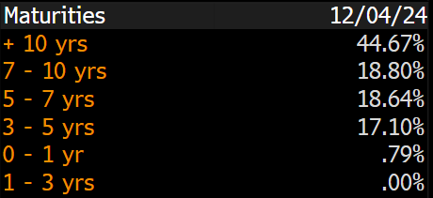

### **3. Income Generation in LQD:**

**LQD** holds U.S. investment-grade corporate bonds, which typically pay interest (or coupons) to bondholders on a regular basis. The income generated from LQD comes from these **coupon payments**, which are the periodic interest payments that bond issuers make to bondholders.

* **Coupon Payments**: These are typically paid semi-annually, which means bondholders receive interest payments twice a year. The coupon is usually fixed at the time of issuance and is paid based on the bond’s face value (principal amount).
* **Yield to Maturity (YTM)**: For those buying bonds in the secondary market, the yield to maturity is a key metric. It reflects the total return expected if the bond is held to maturity, including both coupon payments and any capital gain or loss.

LQD’s income primarily comes from the coupon payments of the bonds it holds. The ETF then distributes these payments to its investors in the form of a dividend.

### **Income Yield in LQD**

The **yield** on LQD reflects the income generated by the ETF relative to its price. The yield is influenced by the coupon payments of the bonds it holds and the market price of the ETF. The **current yield** is calculated by dividing the total annual dividend payments by the price of the ETF.

#### **Income Yield for LQD (as of 2024):**

* **Dividend Yield**: LQD typically has a yield ranging from **3.5% to 4.5%** annually, depending on the market conditions, interest rates, and the specific bonds held within the fund. The yield may fluctuate as bond prices change due to market conditions.
* **Dividend Distribution**: LQD distributes income on a **monthly basis**, which provides investors with a steady stream of income.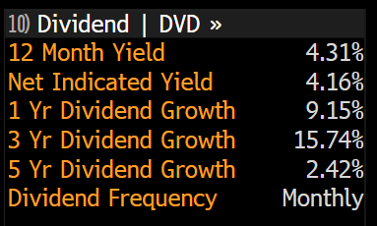

#### **Example of Income Generation:**

If an investor holds **$10,000** in LQD and the ETF has an annual yield of **4%**, the investor would receive **$400** in income over the year. This income would be distributed as **monthly dividends**, roughly **$33.33 per month** (assuming a consistent yield).

### **Comparison with Other Income-Generating Investments**

Let's compare LQD's income potential with some other common investment options:

|  |  |  |  |  |
| --- | --- | --- | --- | --- |
| **Investment Type** | **Typical Yield Range** | **Payment Frequency** | **Risk Level** | **Liquidity** |
| **LQD (Investment-Grade Corporate Bonds)** | 3.5% - 4.5% | Monthly | Moderate (Low risk, but corporate defaults are possible) | High (traded as ETF) |
| **U.S. Treasuries (10-year)** | 3.5% - 4.0% | Semi-annually | Very Low (Backed by U.S. government) | High (widely traded) |
| **High-Yield Bonds (Junk Bonds)** | 6% - 8% | Monthly or Quarterly | High (Higher risk of default) | Moderate (less liquid than LQD) |
| **Dividend Stocks (S&P 500)** | 2% - 3% | Quarterly | Moderate (Stock market volatility) | High (widely traded) |
| **Real Estate Investment Trusts (REITs)** | 5% - 7% | Quarterly | Moderate to High (Market fluctuations, property risk) | High |

* **LQD’s Yield**: Compared to **U.S. Treasuries**, which typically have lower yields (around 3.5-4%), LQD’s yield is slightly higher due to the risk associated with corporate bonds. However, it is lower than high-yield (junk) bonds, which offer higher returns but at greater risk.
* **Dividend Stocks**: While dividend stocks are a popular income investment, their yields (around 2-3%) tend to be lower than LQD’s. Stocks also carry greater volatility and risk than bonds, which may make LQD more attractive for risk-averse investors.

### **How LQD Distributes Income**

LQD’s income is derived from the interest payments made by the underlying corporate bonds in the portfolio. The distribution process works as follows:

1. **Bond Coupon Payments**: The companies whose bonds are held in the fund pay interest (coupons) to the fund.
2. **Pooling of Income**: The ETF collects these coupon payments and then distributes them to shareholders.
3. **Monthly Dividends**: Investors receive monthly dividend payments based on the amount of LQD they own.

#### **Example: Monthly Income Distribution**

Let’s assume LQD holds bonds with an average coupon rate of 4%, and the average market price of LQD is $100. If an investor owns **100 shares of LQD**, which would represent an investment of **$10,000**, the expected annual income would be approximately:

* **Total Annual Income** = 4% of $10,000 = **$400**
* **Monthly Dividend** = $400 ÷ 12 months = **$33.33 per month**

These monthly dividends can be reinvested or used as cash flow, providing a steady income stream.

### **4. Tax Considerations**

While LQD offers a steady stream of income, it's important to keep in mind the tax implications:

* **Interest Income**: The dividends received from LQD are typically treated as **ordinary income** and taxed at the investor’s marginal tax rate, which could be higher than the tax rate on qualified dividends (from stocks).
* **Capital Gains**: If you sell your LQD shares for a profit, any gains would be subject to **capital gains tax**.

LQD is an attractive investment for income-seeking investors due to its relatively high yield (3.5%-4.5% annually) compared to the U.S. Treasuries or dividend stocks. The ETF provides monthly income through dividends from the coupon payments of investment-grade corporate bonds, which can be a stable source of cash flow for investors. It is also less volatile than stocks and junk bonds, making it suitable for conservative investors who prioritize income over capital gains.

By holding LQD, investors get the benefit of predictable income from diversified, high-quality corporate bonds.

This looks like a good investment for the Ingar family considering the adverse risk nature of Peter Ingar. In essence, It provides a source of steady income over a few years with a low risk.

**5. Calculation of Expected Return**

|  |  |  |  |  |
| --- | --- | --- | --- | --- |
| Symbol | Description | Transaction | Quantity | Current Price |
| LQD | ISHARES IBOXX | NYSE | 81 | 110.55 |

We invested $9,000 into 81 of LQD bonds because of the 6 previously stated reasons. We evenly distributed 9% to each of our funds towards 5 out of the 5 bonds we have chosen as we are confident in the diverseness in our portfolio and see them as all attractive investments.

Expected Rate of Return = Rf + B*[E(Rm)-Rf)

Where:

1. Rf = Risk-Free Rate = 4.74% (US Treasury 3 Month Bill)
2. B = Beta = 1.48 measure of LQD’s ETF price volatility
3. E(Rm) = Expected return on the market = our benchmark which is a 10-year average of the S&P 500 = The average rate of return for the S&P 500 since 2012 is 13.22%

Therefore:

Expected Rate of Return = Rf + B*[E(Rm)-Rf]

= 4.74% + 1.48 * [13.22%-4.74%]

= 17.29%

**Investment 9: Vanguard S/T Corp Bond ETF (NYSE: VCSH)**

|  |  |  |  |  |  |  |
| --- | --- | --- | --- | --- | --- | --- |
| 9) | Vanguard S/T Corp Bond ETF | VCSH | NASDAQ STOCK EXCHANE | Malvern**,** Pennsylvania, USA | 8315.6 | 8.33% |

1. Background on the Company

The Vanguard Short-Term Corporate Bond ETF (VCSH) is an exchange-traded fund designed to track the performance of the Bloomberg U.S. 1-5 Year Corporate Bond Index. It invests in a diversified portfolio of investment-grade corporate bonds with maturities between 1 and 5 years. Launched in 2009, VCSH is known for its low expense ratio (around 0.04%) and focus on generating modest income with limited interest rate risk, making it an appealing choice for conservative investors. The fund’s short duration helps minimize price sensitivity to interest rate changes, offering stability and predictable returns.

VCSH is managed by Vanguard, a global investment giant headquartered in Malvern**,** Pennsylvania, USA, with operations across countries including Canada, the United Kingdom, Australia, and various regions in Europe and Asia. Vanguard manages over $8 trillion in assets (as of 2023) and is renowned for its investor-focused philosophy, transparency, and low-cost investment products. Operating under a unique investor-owned structure, Vanguard returns profits to its fundholders in the form of reduced costs. VCSH exemplifies this approach, providing a reliable option for income-focused investors seeking diversification and lower risk compared to equities or longer-term bonds.

1)Valuation Assessment

The Vanguard Short-Term Corporate Bond ETF (VCSH) is a highly efficient and cost-effective investment option for income-focused investors. With an expense ratio of just 0.04%, it ensures that a greater share of returns directly benefits investors, aligning with Vanguard's commitment to low-cost investing. VCSH is designed to closely track the Bloomberg U.S. 1–5 Year Corporate Bond Index, offering a portfolio of investment-grade bonds with strong credit ratings, primarily in the A and BBB categories. This balance between quality and yield makes it a reliable choice for those seeking stable income with limited risk exposure

The ETF’s pricing efficiency further enhances its value, with its Net Asset Value (NAV) remaining closely aligned to its market price. This reflects its robust liquidity and transparent management. VCSH’s short duration mitigates the impact of interest rate volatility, while its diversified portfolio provides exposure to bonds from multiple sectors and issuers. By combining competitive cost structures, credit quality, and efficient pricing, VCSH stands out as a strong contender in the short-term bond market for conservative investors.

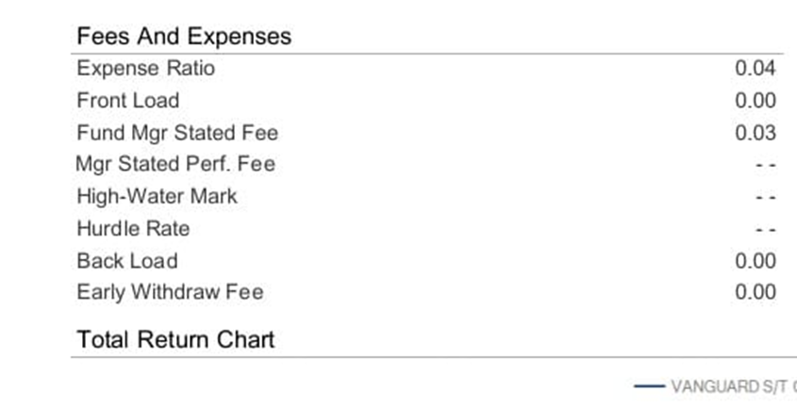

2)Profitability Assessment:

The Vanguard Short-Term Corporate Bond ETF (VCSH) delivers consistent income by investing in investment-grade corporate bonds, balancing yield and risk. While short-term bonds generally yield less than longer-term bonds, they benefit from lower interest rate sensitivity, making them a stable choice. The fund's distribution yield reflects its profitability, offering competitive returns within its category for investors seeking modest but reliable income. With an exceptionally low expense ratio of 0.04%, VCSH ensures that more returns are passed to investors, enhancing its appeal compared to similar ETFs. Its portfolio is characterized by high credit quality, primarily consisting of A and BBB-rated bonds, reducing default risk and supporting steady income. Diversification across sectors, including finance, healthcare, and industrials, with top holdings such as Bank of America, CVS Health, and The Boeing Company, minimizes sector-specific risks. Additionally, its pricing efficiency, demonstrated by a closely aligned Net Asset Value (NAV) and market price, ensures liquidity and minimal trading losses. The broadly diversified portfolio, with the top 10 holdings accounting for only 2% of assets, reduces concentration risk and provides stable returns across market conditions, making it a reliable option for income-focused investors.

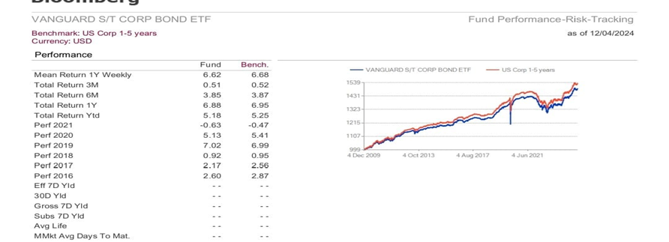

3)Consistent Trailing Dividend Payout or Predictable Income

The Vanguard Short-Term Corporate Bond ETF (VCSH) is structured to provide consistent income primarily through investments in investment-grade corporate bonds. Its dividend payout is aligned with its income generation from bond coupon payments, offering an annualized dividend yield of approximately 3.88% as of recent data. This yield makes it competitive within the corporate bond ETF category and appealing for investors seeking stable, short-term income with relatively low risk .

In terms of cash flow, VCSH benefits from the frequent coupon payments of its high-quality bonds, ensuring regular income distribution to investors. Additionally, its portfolio's low expense ratio of 0.04% helps maximize the return passed on to shareholders, enhancing cash flow stability. The fund's significant diversification—spreading assets across thousands of holdings and sectors—reduces dependence on any single bond issuer, further securing steady income streams. These factors collectively make VCSH a reliable choice for income-focused investors

The table provides information about Vanguard Short-Term Bond ETF dividends, including announced dates, periods, amounts, yields, ex-dividend dates, record dates, and payable dates. Here's an explanation of the yield ratio and its implications for investors in short-term bonds:

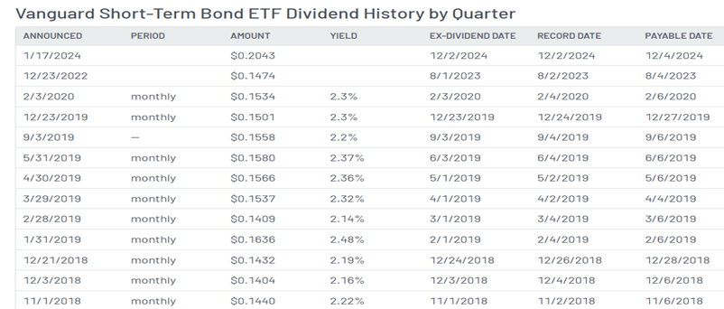

The Vanguard dividend yield ratio represents the annualized dividend payments as a percentage of the ETF's share price, reflecting the return investors earn from dividends relative to the fund's price. Over the period shown, the yield fluctuated, aligning with market interest rate trends and central bank policies. For instance, yields ranged from 2.14% in February 2019 to 2.37% in May 2019, showing sensitivity to economic conditions. These fluctuations highlight the ETF's ability to adjust payouts based on the changing interest rate environment, providing investors with a reliable income stream while maintaining stability in response to market dynamics.

4). High Market Capitalization VCSH has a substantial market presence, with billions in assets under management. This high market capitalization reflects strong investor confidence, and ensures liquidity, allowing easy trading at a minimal cost. Its size and reputation further cement its position as a market leader in bond ETFs. As of December 2024, the Vanguard Short-Term Bond ETF (BSV) has a market capitalization of approximately $33.18 billion. This ETF primarily invests in short-term, high-quality bonds, making it an attractive choice for conservative investors looking for stability, low-interest rate sensitivity, and consistent income. Its substantial market size reflects its popularity and the broad appeal of its low-risk investment profile.

[Vanguard uses the Russell 3000 index as the basis for determining the market capitalization of its domestic stock funds and variable annuity portfolios, Vanguard ETF® Shares, and the target domestic stock portion of its balanced and global funds1](https://www.bing.com/ck/a?!&&p=e3395966c92efecd607639efed36ad5eb126cef6cbbdfbaed24654ba2a2f06dbJmltdHM9MTczMzQ0MzIwMA&ptn=3&ver=2&hsh=4&fclid=1d91247a-c895-6586-0d4b-378ec93f64b7&u=a1aHR0cHM6Ly9wZXJzb25hbC52YW5ndWFyZC5jb20vdXMvY29udGVudC9NeVBvcnRmb2xpby9hbmFseXRpY3MvcHdMTU1ya3RDYXBpdGFsaXphdGlvbkNvbnRlbnQuanNwP21zb2NraWQ9MWQ5MTI0N2FjODk1NjU4NjBkNGIzNzhlYzkzZjY0Yjc&ntb=1). [The market capitalization definitions for Vanguard funds are based on the Russell 3000 index**2**](https://www.bing.com/ck/a?!&&p=c459a64734d7cc492f9d3ed9ff05f8da80e426642bdc01b2d9a21ae21993dafdJmltdHM9MTczMzQ0MzIwMA&ptn=3&ver=2&hsh=4&fclid=1d91247a-c895-6586-0d4b-378ec93f64b7&u=a1aHR0cHM6Ly9wZXJzb25hbC52YW5ndWFyZC5jb20vdXMvY29udGVudC9NeVBvcnRmb2xpby9hbmFseXRpY3MvcHdMTU1ya3RDYXBEZXRhaWxzQ29udGVudC5qc3A_bXNvY2tpZD0xZDkxMjQ3YWM4OTU2NTg2MGQ0YjM3OGVjOTNmNjRiNw&ntb=1).

5)Projected Future Long-Term Growth Based on Historical Data Overtime

The Vanguard Short-Term Corporate Bond ETF (VCSH) has demonstrated steady historical performance, offering both price stability and consistent income distribution. Over the past five years, the ETF has delivered an average annualized return of 2.01% and a dividend growth rate of 5.14%, reflecting its focus on high-credit-quality corporate bonds. With assets under management of approximately $41.48 billion as of November 2024 and a low expense ratio of 0.04%, VCSH is an appealing option for conservative, cost-conscious investors. It offers a balance of minimal risk and steady income, making it particularly attractive to those seeking capital preservation and gradual returns.

The ETF experienced a significant downturn in 2020 due to the market volatility triggered by the COVID-19 pandemic, which caused a sharp decline in bond prices as investors shifted to safer assets. However, VCSH quickly rebounded following emergency Federal Reserve measures, including bond-buying programs, to restore liquidity. Vanguard’s focus on short-duration, high-credit-quality bonds further strengthened investor confidence during this period of recovery. Looking forward to 2025, VCSH is projected to maintain moderate, stable growth driven by improving economic conditions and continued demand for fixed-income assets, positioning it as a reliable long-term investment for conservative investors focused on stability and gradual capital appreciation.

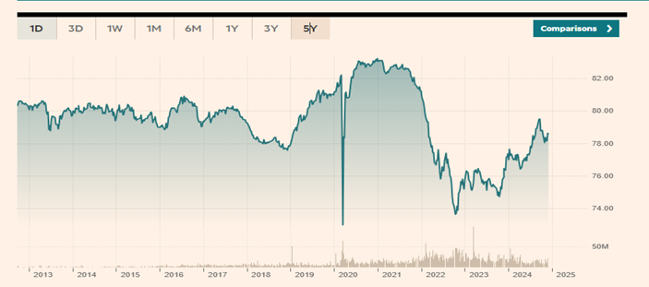

6)Industry Expert Recommendations:

Financial analysts often recommend the Vanguard Short-Term Corporate Bond ETF (VCSH) for its stability, low cost, and reliable returns. This recommendation stems from several key factors: its focus on high-credit-quality, short-duration corporate bonds, which offer lower volatility and minimize interest rate risk compared to long-term bonds. The ETF's ultra-low expense ratio of 0.04% makes it an attractive option for cost-conscious investors. VCSH is consistently ranked among the top bond ETFs by platforms like Morningstar, where it receives praise for its ability to generate steady income while maintaining a balanced approach to risk management. Experts highlight its value in conservative portfolios, particularly during periods of market volatility, as it provides a stable income stream and reduces exposure to longer-term market fluctuations. The fund’s strong historical performance, combined with its risk-conscious approach, positions it as a dependable choice for investors seeking gradual growth and capital preservation.

7)The projected long-term growth of the Vanguard Short-Term Corporate Bond ETF (VCSH) is closely tied to the overall health of the U.S. economy. Positive macroeconomic factors, such as moderate GDP expansion and low default rates among investment-grade corporate issuers, create a favorable environment for the ETF. The continued growth of the U.S. economy supports the performance of corporate issuers in VCSH’s portfolio, as they are well-positioned to benefit from an improving economic outlook. With stable economic conditions, VCSH is likely to see sustained demand for its high-credit-quality, short-duration bonds, contributing to its potential for steady returns. Moreover, interest rates and consistent corporate earnings further enhance the ETF’s future growth prospects.

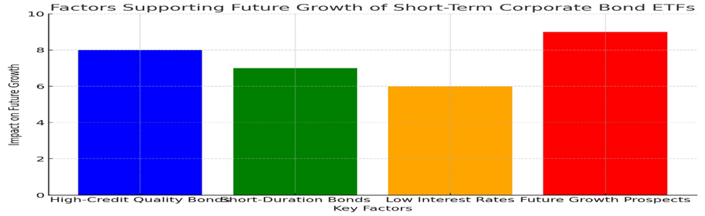

|  |  |  |  |  |
| --- | --- | --- | --- | --- |
| Symbol | Description | Transaction | Quantity | Current Price |
| VCSH | NYSE | Vanguard Guard Short-Term Corporate Bond ETF | 114 | 78.65 |

We invested $9,000 approximately into 114 of TLT bonds because of the 6 previously stated reasons. We evenly distributed 9% to each of our funds towards 5 out of the 5 bonds we have chosen as we are confident in the diversity in our portfolio and see them as all attractive investments.

For the VCSH Bonds:

Expected Rate of Return = Rf + B*[E(Rm)-Rf)

Where:

1. Rf = Risk-Free Rate = 4.74% (US Treasury 3 Month Bill)
2. B = Beta = 0.48 measure of VCSH’s ETF price volatility
3. E(Rm) = Expected return on the market = our benchmark which is a 10-year average of the S&P 500 = The average rate of return for the S&P 500 since 2012 is 13.22%

Therefore:

Expected Rate of Return = Rf + B*[E(Rm)-Rf]

= 4.74% + 0.48 * [13.22%-4.74%]

= 8.81%

**Investment 10: Intuitive Surgical Inc. (NYSE: ISRG)**

|  |  |  |  |  |  |  |  |
| --- | --- | --- | --- | --- | --- | --- | --- |
| 10 | Intuitive Surgical, Inc  (ISRG) | Common Stock | NASDAQ  GS | Sunnyvale, California, USA | 13550 |  | 13.434% |

1. Background of the company

Intuitive Surgical (ISRG), founded in 1995 and headquartered in Sunnyvale, California, is a pioneering leader in robotic-assisted surgery. Its flagship product, the da Vinci Surgical System, revolutionized minimally invasive surgery by improving precision, reducing complications, and enhancing patient recovery. The company also introduced the Ion endoluminal system, a cutting-edge device for minimally invasive lung biopsies.

ISRG operates a robust business model, earning revenue through robotic system sales, consumable instruments, accessories, and maintenance services. Its strong recurring income stream provides financial stability, with 2024 revenues reaching $7.87 billion. Approximately 66% of its revenue comes from the U.S., while 34% stems from the international market with a market capitalization of $194.52 billion, ISRG remains at the forefront of healthcare innovation. The company’s high margins and profitability (28.51% net margin in 2024) reflect its efficiency and market dominance. By investing heavily in research and development, ISRG continues to advance robotic-assisted technologies, further solidifying its leadership position in the growing field of minimally invasive surgery.

Intuitive Surgical’s commitment to improving patient outcomes and advancing surgical techniques ensures its continued impact on global healthcare.

1. Fundamental Analysis: *Reasons why we chose to invest in this security*

Reason 1: Valuation Assessment: Reasonable Price-to-Earnings (P/E) Ratio

For Intuitive Surgical (ISRG), the Price-to-Earnings (P/E) Ratio is 87.84 (trailing) and 72.86.

· These P/E ratios are significantly higher than the healthcare sector average, reflecting strong market confidence in ISRG’s growth potential but suggesting it may be overvalued compared to peers. Investors should note that while high P/E ratios are common in high-growth sectors, ISRG's PEG ratio (4.04) indicates its valuation might not fully align with its growth rate .

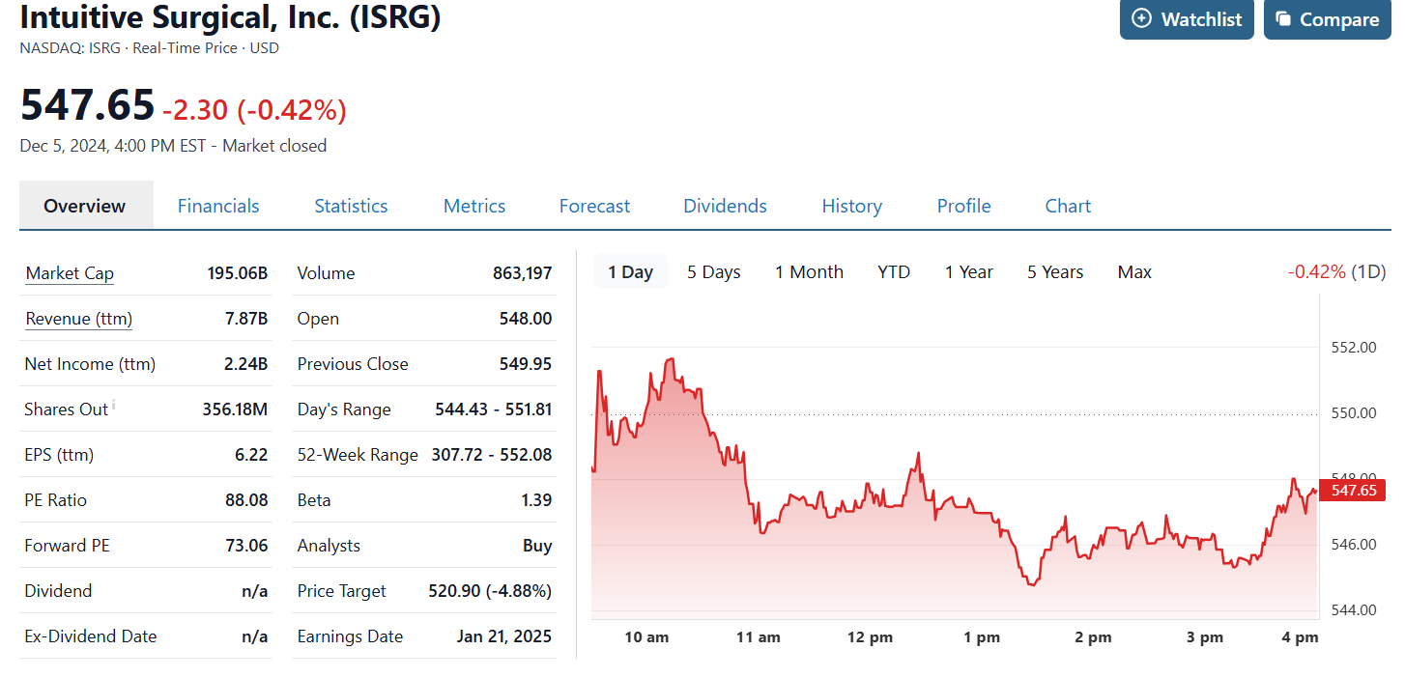

Reason 2: Price-to-Book Ratio

Intuitive Surgical (ISRG) has a Price-to-Book (P/B) ratio of 12.57, meaning the company’s market value is over 12 times its book value (assets minus liabilities) This high ratio reflects the premium investors place on the company's future earnings potential and dominance in robotic-assisted surgery. The elevated P/B ratio is common in technology-driven healthcare companies like ISRG, where intangible assets such as patents, intellectual property, and brand equity are not fully captured in book value calculations. These intangibles drive significant value for ISRG, which has revolutionized surgery with its da Vinci robotic systems, establishing itself as a market leader in minimally invasive procedures Compared to traditional healthcare companies, ISRG’s high P/B ratio suggests robust growth expectations. However, it also indicates that investors are paying a significant premium for the company’s innovation and future potential rather than its current tangible assets. This can be a risk if growth slows, or expectations aren’t met. In summary, ISRG’s P/B ratio reflects strong investor confidence and its leadership in the healthcare sector. However, prospective investors should balance this metric with profitability measures and growth forecasts to ensure the valuation aligns with their investment goals.

Reason 3: Technological innovation

ISRG continues to innovate with new products like the Ion endoluminal system, which expands its market footprint, particularly in lung biopsy procedures.

Reason 4: High Market Capitalization

As of 2024, ISRG has a market capitalization of approximately $194.52 billion.

This positions it as one of the largest companies in the healthcare technology sector, driven by its innovative robotic surgical systems and strong global market presence.

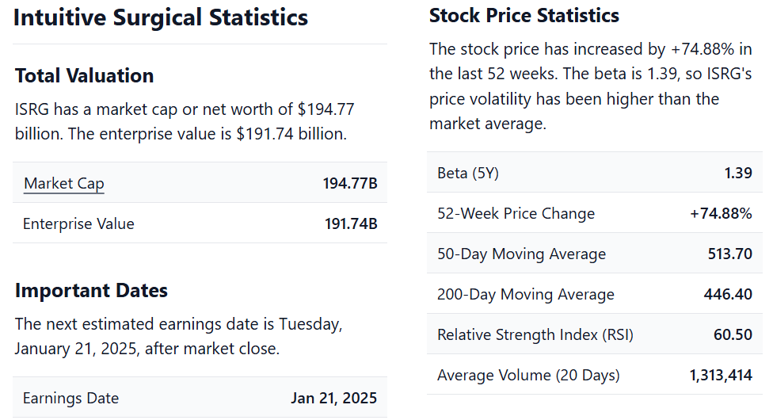

Reason-5: Historical Trend

Intuitive Surgical (ISRG) has demonstrated a strong and steady historical trend of growth since its founding in 1995. After its IPO in 2000, the company faced challenges in gaining widespread acceptance of its da Vinci Surgical System, a robotic-assisted surgery platform. However, over time, advancements in the system's capabilities, along with strong evidence of improved patient outcomes, led to broader adoption across healthcare institutions. As demand for minimally invasive surgeries grew, ISRG expanded its market share and product offerings, including the Ion endoluminal system for lung biopsies.

The company’s revenue growth accelerated through the 2000s and 2010s, driven by expanding international markets and a growing installed base of robotic systems. By 2024, ISRG's market capitalization had reached $194.52 billion, solidifying its position as a leader in the healthcare technology sector

Despite the occasional volatility in its stock price, ISRG has consistently outperformed many other healthcare stocks, supported by its innovative products and strong financial performance. The company’s continued reinvestment in research and development has ensured it remains at the forefront of surgical robotics, positioning ISRG well for future growth in the expanding field of robotic surgery.

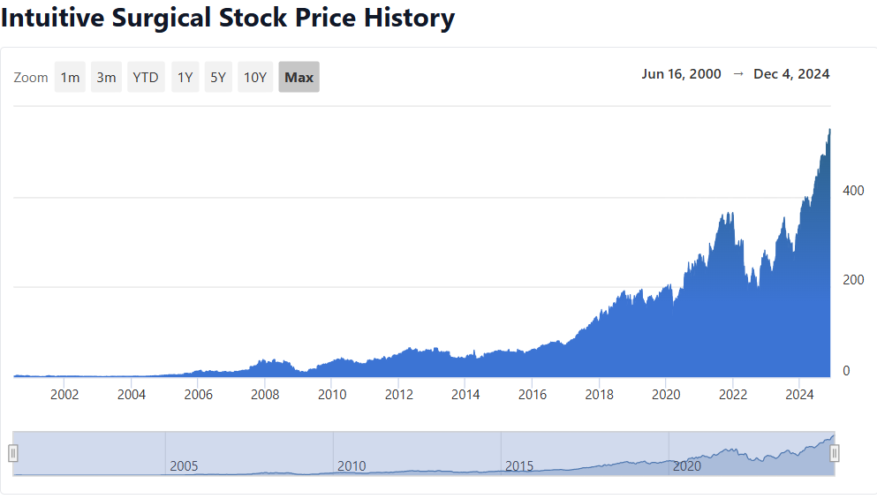

Reason-6: Industry Expert Recommendation

Industry experts are generally optimistic about investing in Intuitive Surgical (ISRG). As of late 2024, many analysts have issued a "Strong Buy" recommendation, with a significant majority (over 60%) of recommendations favouring a positive outlook on the stock Key factors contributing to this sentiment include the company's leadership in the robotic-assisted surgery field, driven by their innovative da Vinci and Ion surgical systems. Additionally, Intuitive Surgical is making strides in advancing its AI and machine learning technologies, which enhance the precision of robotic surgery However, there are some cautionary notes from analysts. Concerns around increasing competition, such as lower-priced alternatives and ongoing legal challenges, have the potential to affect the company's pricing strategy Despite these risks, the overall sentiment remains strong, with analysts continuing to project growth driven by ISRG's technological innovations and its strong market position Investors looking for a growth opportunity in the healthcare technology sector may find ISRG's stock attractive, but they should also be mindful of the competitive and regulatory challenges that could impact future performance.

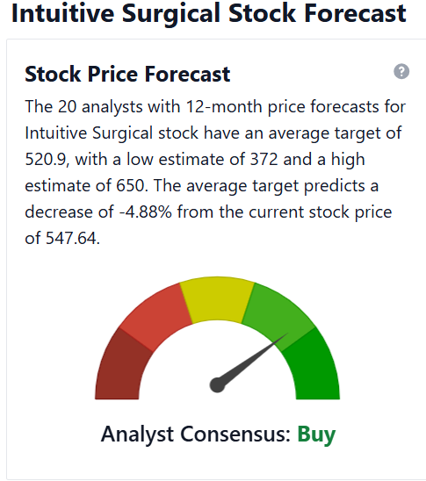

1. Amount Invested and Why

|  |  |  |  |  |
| --- | --- | --- | --- | --- |
| Symbol | Description | Transaction | Quantity | Current Price |
| ISRG | ISRG INC | Open Market | 25 | 542.00 |

We invested $13,550 into 25 of ISRG Stocks because of the 6 previously stated reasons. We evenly distributed 13.4% to each of our funds towards 5 out of the 6 stocks we have chosen as we are confident in the diverseness in our portfolio and see them as all attractive investments.

1. Expected return of stock

Expected Rate of Return = Rf + B*[E(Rm)-Rf)

Where:

· Rf =4.186%=0.04186

· β=1.21\beta = 1.21β=1.21

· E(Rm)=12.30%=0.1230E(R_m) = 12.30\% = 0.1230E(Rm )=12.30%=0.1230

1. E(Rm) = Expected return on the market = our benchmark which is a 10-year average of the S&P 500 = The average rate of return for the S&P 500 since 2012 is 16.4%

Therefore

Expected Rate of Return=0.04186+1.21×(0.1230−0.04186)= 14.00%

**Investment 11: iShares 3-7 Year Treasury Bond ETF (NYSE: IEI)**

Background

The iShares 3-7 Year Treasury Bond ETF (IEI) is an exchange-traded fund (ETF) that primarily tracks the performance of U.S. Treasury bonds with maturities between 3 and 7 years. Managed by BlackRock, IEI is part of the popular iShares Treasury bond ETF suite and offers investors exposure to mid-duration U.S. government bonds. Here’s an overview:

Key Features:

1. Objective: The fund seeks to replicate the investment results of the ICE U.S. Treasury 3-7 Year Bond Index, which includes Treasury securities with maturities between 3 and 7 years.
2. Holdings: IEI invests exclusively in U.S. Treasury bonds, ensuring high credit quality (backed by the U.S. government).
3. Duration and Interest Rate Sensitivity:
   1. The fund has an intermediate duration, making it moderately sensitive to interest rate changes.
   2. Rising rates may lead to price declines, but the impact is less severe than in longer-duration funds.
4. Yield and Returns:
   1. Yields are influenced by the current interest rate environment and the average yield of underlying bonds.
   2. Investors typically use IEI for income generation and stability, not high returns.

Suitability:

IEI is often used by investors seeking:

* Income with low credit risk.
* Diversification in a portfolio, balancing riskier asset classes like equities.
* A hedge against economic uncertainty, as Treasuries are considered safe-haven assets.

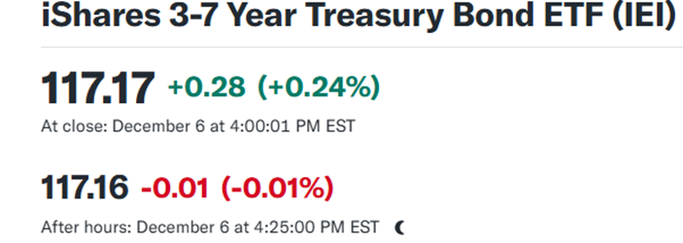

**Reasons to invest in the Bond:**

**Reason 1) Valuation Assessment (Low P/E Ratio and Favorable Comparison to Industry Average)**

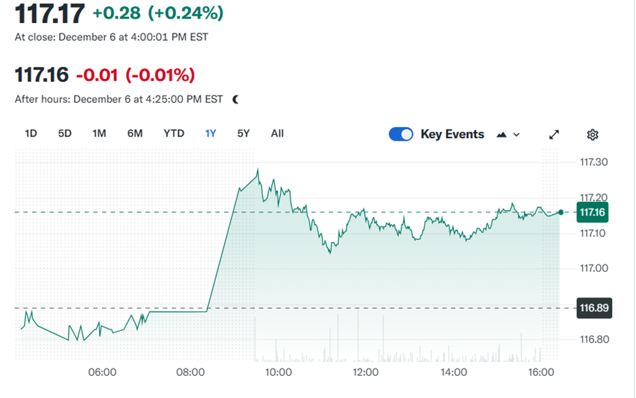

The valuation assessmentof iShares 3-7 Year Treasury Bond ETF (IEI) can be analyzed through its pricing relative to market conditions and comparable funds. While traditional P/E ratios are more common in equity analysis, for bond ETFs like IEI, valuation is often gauged through yield, price-to-duration metrics, and comparisons to similar Treasury funds.

### Low P/E Ratio:

For bond ETFs, low valuation often stems from higher bond yields or discounted bond prices within the portfolio. Rising interest rates in the broader market may have suppressed bond prices, creating an opportunity to invest in IEI at attractive levels. This trend indicates potential for higher returns as bond prices recover with rate stabilization or declines.

### Favorable Comparison to Industry:

IEI’s valuation can be compared to similar mid-duration Treasury ETFs. With a focus on U.S. government bonds (offering high credit quality), IEI provides relatively stable returns and lower risk compared to corporate bond ETFs. Its intermediate duration balances sensitivity to interest rate changes while offering a higher yield than short-term Treasury ETFs. This makes it a compelling choice for risk-averse investors seeking consistent income and modest price appreciation.

IEI’s strong fundamentals and attractive pricing position it as a valuable investment in the current market climate.

**Reason 2) Valuation Assessment (Low P/B Ratio and Favorable Comparison to Industry Average)**

The valuation assessment of iShares 3-7 Year Treasury Bond ETF (IEI) can also be evaluated through the lens of its Price-to-Book (P/B) ratio, an important metric for assessing the market value of the fund compared to the net asset value (NAV) of its underlying holdings.

### Low P/B Ratio:

A low P/B ratio indicates that the ETF’s market price is trading close to or below the book value of its underlying assets. For bond ETFs like IEI, this is often a result of broader market factors such as rising interest rates, which can drive bond prices lower, pushing their market values below their par values. Such a scenario may signal an undervaluation, making the ETF an attractive investment opportunity as it has the potential for price recovery when rates stabilize or decline.

### Favorable Comparison to Industry:

Compared to other mid-duration bond ETFs, IEI’s P/B ratio could be more favorable due to its exclusive focus on U.S. Treasury bonds, which offer high credit quality and minimal default risk. Unlike corporate bond ETFs, Treasury-focused funds are less affected by credit spreads, further enhancing their appeal during periods of market volatility.

This low P/B ratio, coupled with IEI’s high-quality holdings, positions it as a strong option for value-focused investors seeking stability and potential capital appreciation.

**Reason 3) Profitability Assessment**

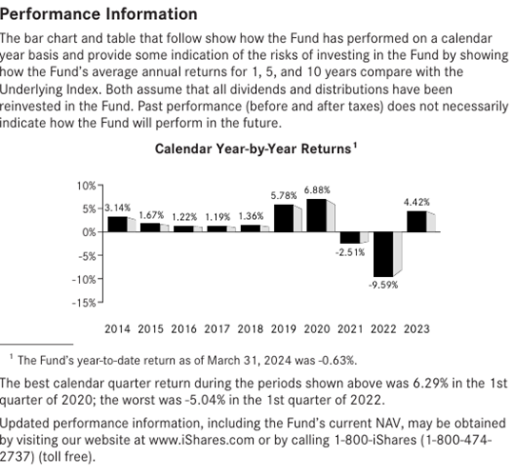

Theprofitability assessment of iShares 3-7 Year Treasury Bond ETF (IEI) evaluates its ability to deliver consistent returns through income and price stability. Unlike equities, where profitability is tied to earnings growth, bond ETFs like IEI focus on yield, risk-adjusted returns, and cost efficiency.

### 1. Yield and Income Generation:

IEI primarily generates returns from interest income paid by its holdings of U.S. Treasury bonds. With an intermediate duration of 3–7 years, it offers a higher yield than short-term bond ETFs while maintaining lower interest rate sensitivity than long-term bond funds. The rising interest rate environment has increased bond yields, enhancing IEI's appeal for income-seeking investors.

### 2. Capital Stability:

Investing exclusively in U.S. Treasury securities, IEI provides unmatched credit quality and minimal default risk, ensuring consistent income and reduced-price volatility. This makes it a dependable choice for investors prioritizing capital preservation over aggressive growth.

### 3. Low Expenses:

IEI’s expense ratio, typically around 0.15%, is competitive and ensures that more of the returns generated are passed on to investors, maximizing profitability over the long term.

In summary, IEI’s profitability stems from its reliable income, low risk, and cost efficiency, making it an attractive option for conservative investors seeking stability and steady returns.

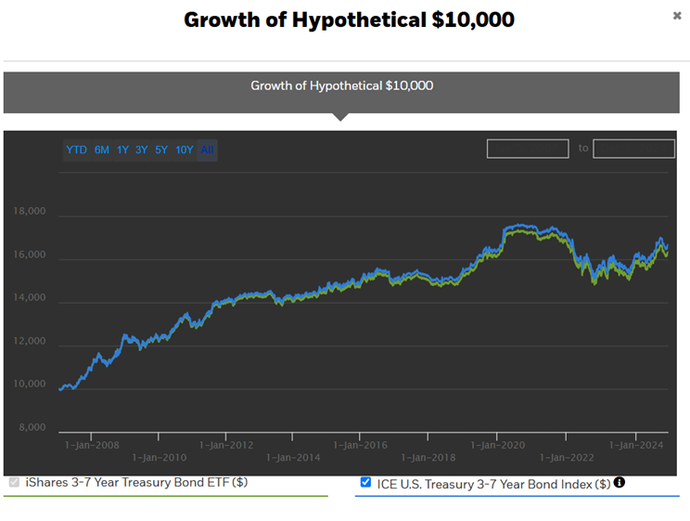

**Reason 4) Consistent Trailing Dividend Payout or Predictable Income (Bond)**

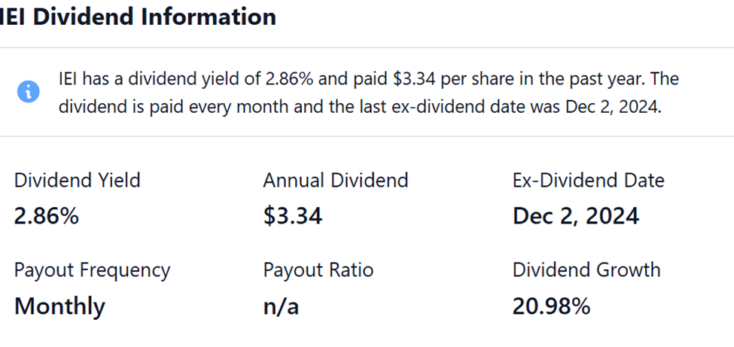

**Reason 5) High Market Capitalization**

The iShares 3-7 Year Treasury Bond ETF (IEI) is a highly liquid and stable investment vehicle that primarily tracks U.S. Treasury bonds with maturities between 3 and 7 years. Its high marketcapitalization reflects strong investor demand, providing several key advantages.

Firstly, IEI’s large market cap ensures liquidity, enabling investors to buy and sell shares efficiently with minimal transaction costs. This is especially beneficial for institutional investors who require flexibility and cost-effective entry and exit points. High liquidity also results in tight bid-ask spreads, which help reduce trading costs for individual investors.

Secondly, the fund's size indicates investor confidence in its ability to generate stable income through the interest payments of U.S. Treasury bonds. With a focus on low-risk, high-credit-quality assets, IEI is a trusted choice for those seeking capital preservation and consistent returns.

Finally, a high market cap contributes to the ETF's stability, particularly in volatile markets. The large scale and underlying quality of U.S. Treasuries provide resilience, making IEI a safe and reliable option for conservative investors looking for moderate yield and security.

In summary, IEI’s high market capitalization enhances its liquidity, investor trust, and overall stability, making it an attractive choice for both individual and institutional investors.

**Reason 6) Projected Future Long-Term Growth Based on Historical Data**

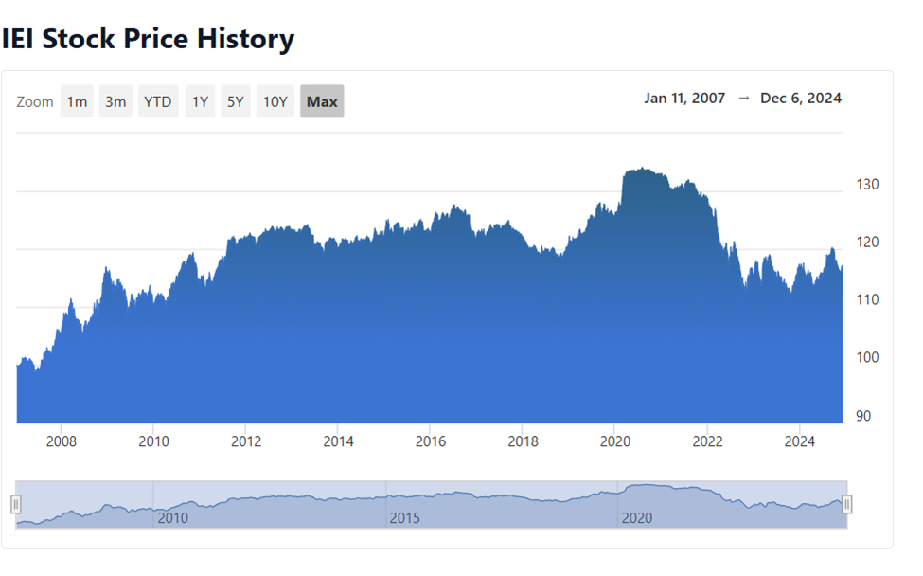

**Reason 7) Industry Expert Recommendations**

Here are a few industries expert recommendations for investing in iShares 3-7 Year Treasury Bond ETF (IEI):

1. For Conservative Income Seekers:

* Recommendation: IEI is ideal for conservative investors prioritizing income generation and capital preservation. Its focus on U.S. Treasury bonds provides a low-risk investment with stable returns. Experts suggest allocating a portion of the portfolio to IEI to generate consistent income while minimizing exposure to market volatility.

2. During Rising Interest Rates:

* Recommendation: With rising interest rates, IEI's moderate duration helps mitigate the risk of price declines compared to long-duration bonds. Experts advise investors to consider IEI as a safe haven for protecting against rate increases, as the ETF offers relatively higher yields without the extreme price sensitivity of long-term Treasury bonds.

3. As Part of a Diversified Portfolio:

* Recommendation: IEI is an excellent choice for diversifying a portfolio, particularly for investors with significant equities exposure. Adding Treasury bond ETFs like IEI can offer downside protection and lower volatility in case of stock market downturns. Financial advisors suggest allocating 10–20% of a portfolio to bonds for balance.

4. In Uncertain Economic Environments:

* Recommendation: Experts recommend holding IEI in portfolios during times of economic uncertainty or market turbulence. U.S. Treasuries are considered a safe-haven asset, providing stability when other investments, such as equities, may be more volatile.

These recommendations highlight how IEI can fit into various investment strategies, offering a mix of safety, income, and portfolio balance.

1. **Amount Invested and Why**

|  |  |  |  |  |
| --- | --- | --- | --- | --- |
| Symbol | Description | Transaction | Quantity | Current Price |
| IEI | Ishares 3–7-year treasurybond | NASDAQ | 77 | 117.13 |

We invested $9000 into 77 of EIE Bond ETFs because of the 6 previously stated reasons. We evenly distributed 9.00% to each of our funds towards 5 out of the 5 bonds we have chosen as we are confident in the diverseness in our portfolio and see them as all attractive investments.

For the IEI bonds

Expected Rate of Return = Rf + B*[E(Rm)-Rf)

Where:

1. Rf = Risk-Free Rate = 4.74% (US Treasury 3 Month Bill)
2. B = Beta = 0.7 measure of IEI price volatility
3. E(Rm) = Expected return on the market = our benchmark which is a 10-year average of the S&P 500 = The average rate of return for the S&P 500 since 2012 is 13.22%

Therefore:

Expected Rate of Return = Rf + B*[E(Rm)-Rf]

= 4.74% + 0.7 * [13.22%-4.74%]

= 10.68%

**References**

*JNJ - Johnson & Johnson PE ratio, current and historical analysis*. (December 1, 2024). <https://fullratio.com/stocks/nyse-jnj/pe-ratio>

Barchart. (2024, November 8). Are Wall Street analysts predicting Johnson & Johnson stock will climb or sink? *Nasdaq*. <https://www.nasdaq.com/articles/are-wall-street-analysts-predicting-johnson-johnson-stock-will-climb-or-sink>

Waldstreicher, J. (2021, August 31). *How Johnson & Johnson Made Hard Decisions During Covid*. Harvard Business Review. <https://hbr.org/2021/06/how-johnson-johnson-made-hard-decisions-during-covid>

Cattlin, R. (2023, May 4). *Johnson & Johnson spin off: what does it mean for JNJ shares?* Forex.com. <https://www.forex.com/en-ca/news-and-analysis/johnson-and-johnson-spin-off/>

Stock Analysis. (n.d.). Tesla Inc. financials. Retrieved from <https://stockanalysis.com>

Yahoo Finance. (n.d.). Tesla Inc. key statistics. Retrieved from <https://finance.yahoo.com>

Reuters. (2024, October 24). Tesla gives its faithful just enough good news. Retrieved from <https://www.reuters.com>

Tesla Inc. (n.d.). Official company information. Retrieved from [https://www.tesla.com](https://www.tesla.com/)

Alphabet Inc. (2023). Alphabet Inc. 2022 Annual Report. Alphabet Inc. Retrieved from<https://abc.xyz/investor>

Morningstar. (2024). Alphabet Inc. Stock Analysis. Morningstar. Retrieved from <https://www.morningstar.com/stocks/xnas/goog/quote>

Pappas, A. (2024, January 15). Alphabet Inc. stock: Valuation, financial performance, and outlook. Forbes. Retrieved from <https://www.forbes.com/sites/alphabets-stock-analysis>

Yahoo Finance. (2024). Alphabet Inc. (GOOG) Stock Profile & Summary. Yahoo Finance. Retrieved from <https://finance.yahoo.com/quote/GOOG>

Bloomberg. (2024). *BRK/B: Berkshire Hathaway Inc Stock Price Quote*. Retrieved from <https://www.bloomberg.com/quote/BRK%2FB%3AUS>

Bloomberg. (2024). *BRK: Berkshire Hathaway Inc Stock Price Quote*. Retrieved from <https://www.bloomberg.com/quote/BRK%3AUS>

Bloomberg. (2024). *Vanguard Tax-Exempt Bond Index Fund ETF (VTEB)*. Bloomberg. Retrieved from <https://www.bloomberg.com/quote/VTEB:US>

Vanguard. (2024). *Vanguard Tax-Exempt Bond Index Fund ETF (VTEB)*. Vanguard. Retrieved from <https://investor.vanguard.com/etf/profile/VTEB>

IEI (2024). *iShares 3-7 Year Treasury Bond ETF. Retrieved from https://stockanalysis.com/etf/iei/*